Scholarships and Fellowships Flowchart

If you’re in your...
With this GPA...
Interested in opportunities for...

Flip this sheet over to learn more about these awards:

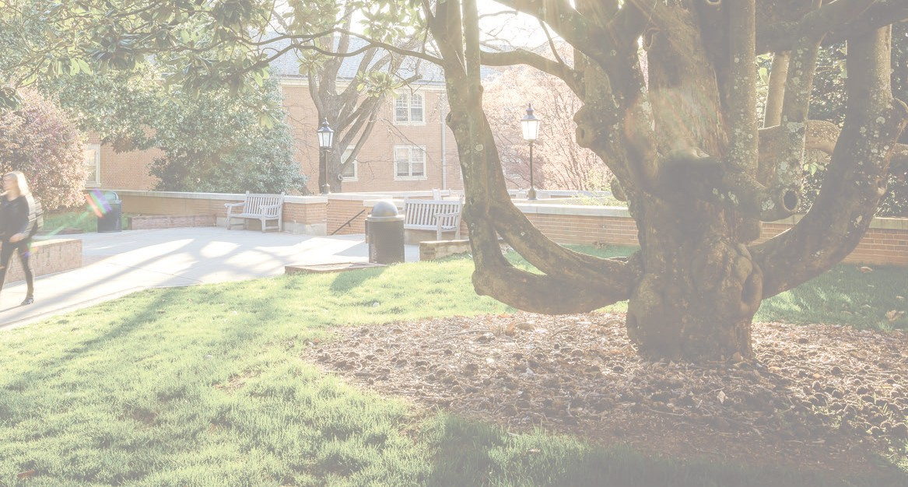
4th Year
(and beyond!)
3.7+ | Graduate Study | Rhodes*, Marshall*, Mitchell*, Gates-Cambridge, Knight-Hennessy Scholars, P.D. Soros Fellowship for New Americans, Schwarzman*, Erasmus, Ertegun
 | Public Service | Huntington, James C. Gaither Junior Fellows (Carnegie),* Hertog War, Hertog Political
3.2+ | Public Service | Capital Fellows, Coro Fellowship, Pickering, Payne Fellowship, Rangel Graduate Fellowship, Rangel Summer Enrichment, Lead for America (2.7+), Venture for America (2.7+), Rudolph Foundation (2.7+), Scoville Peace Fellowship
 | International & Language | Boren, Critical Language, DAAD, Fulbright*, Gilman, Luce*, Yenching, Freeman-Asia (2.8+),  Humanity in Action, Wattles (2.7+)
 | Social Science Research | NSF Graduate Research Fellowship

3rd Year
Wake Forest Research Fellowships, Wake Forest Arts & Humanities Research Fellowships, Starr Travel Grants
Research
3.0+
Boren, Critical Language, Freeman-Asia (2.8+), DAAD, Gilman, Humanity in Action, Richter
International & Language
Udall*, Pickering, Phi Beta Kappa, PPIA Summer Institute, Rangel Summer Enrichment, Rudolph Foundation (2.7+)
Public Service

3.2+
Beinecke*
Arts & Humanities
Truman Scholarship*, Hertog War, Hertog Political
Public Service

3.7+
2nd Year
WF Research Fellowship, WF Arts & Humanities Research Fellowship, Starr Travel Funds
Research
3.0+
Boren, Critical Language, DAAD, Freeman-Asia (2.8+), Gilman, Humanity in Action
International & Language
Phi Beta Kappa, Rangel Summer Enrichment Program, Rudolph Foundation (2.7+)
Public Service

3.2+
Fulbright UK Summer Institute
International & Language
Hertog War, Hertog Political, Mount Vernon Leadership Fellows (3.4+), Public Policy Leadership Conference at Harvard’s Kennedy School (3.5+)
Public Service

3.7+
1st Year
WF Research Fellowship, WF Arts & Humanities Research Fellowship, Starr Travel Funds
Research
3.0+
Phi Beta Kappa,Public Policy Leadership Conference at Harvard’s Kennedy School (3.5+), Hertog Political
Public Service
3.2+
Boren, Critical Language, DAAD, Freeman-Asia (2.8+), Gilman, Fulbright UK Summer Institute (3.7+)
International & Language
3.2+

EXTERNAL OPPORTUNITIES
The Beinecke Scholarship Program: Funding for graduate study in arts, humanities, or social sciences for juniors who have received need-based aid.
Boren Awards for International Study: Boren Scholarships fund undergraduates to study less commonly taught languages abroad and who wish to work in the federal national security area. Capital Fellows Program: 10-11 month full-time program for recent grads at a California legislative, executive, or judicial branch oﬃce with monthly stipend and beneﬁts. 2.5 minimum GPA. James C. Gaither Junior Fellows Program (Carnegie)*: For graduating seniors or individuals who have graduated within the past academic year who are interested in international aﬀairs
research. One-year research fellowship in Washington, D.C. through the James C. Gaither Fellows Program and Carnegie Foundation.
The Critical Language Scholarship (CLS): US State
Department funded eight-week summer language institutes abroad in critical-need languages.
Coro Fellowship: Nine-month fellowship with living stipend that rotates passionate future leaders through multiple sectors. Open to seniors/recent grads.
DAAD: Wide variety of summer, semester, and yearlong intern- ships/research/study in all ﬁelds in Germany.
Erasmus Mundus Scholarship Program: Funds graduate study throughout the European Union. Must study at an Erasmus exchange partner, are exempted from paying fees, registration, etc. Ertegun Graduate Scholarship Programme: 100% covered program studying at Oxford University for graduate studies in the Humanities, living on campus with mentorship from Oxford Faculty as part of the programme.
Freeman-Asia: Freeman Awards for Study in Asia provides
scholarships for U.S. undergraduate students with ﬁnancial need to study abroad in East or Southeast Asia.
Fulbright U.S. Student Program*: The Fulbright U.S. Student program oﬀers English Teaching Assistant Awards, Open Study/ Research Awards, and National Geographic Digital Storytelling fellowships for work and study abroad for one year.
Fulbright U.K. Summer Institute: Three, four, or ﬁve-week academic and cultural summer programs for freshmen and sophomores.
Gates-Cambridge Scholarship: Post-undergraduate study at Cambridge University in all ﬁelds. Applicants must show evidence of commitment to improving the lives of others.
Benjamin A. Gilman International Scholarship: The Gilman Scholarship enables students with ﬁnancial need to study or intern abroad, thereby gaining skills critical to our national security and economic competitiveness.
Hertog War Studies Program: Fully funded 2-week summer study program, including housing, meals, subsidized transportation. Focus on theory, practice, organization, and control of war and mili- tary forces. Open to advanced undergraduate students, 3.75 GPA. Hertog Political Studies Program: 7-week political seminar program; includes housing and $2,000 stipend.
Humanity in Action Fellowship: Four-week summer programs for the study of minority rights and research exploring how and why individuals and societies have resisted intolerance and protected democratic values.

The Samuel Huntington Public Service Award: provides a
$15,000 stipend for a graduating college senior to pursue one year of public service anywhere in the world. The award allows recipients
to engage in a meaningful public service activity for one year before proceeding on to graduate school or a career.
Knight-Hennessy Scholars: Full funding for graduate study at Stanford University. Applicants should demonstrate leadership, civic commitment, and want to join a multidisciplinary community dedi- cated to ﬁnding creative solutions to the world’s greatest challenges. Lead for America Fellowship: Two-year paid fellowship for re- cent grads dedicated to building community through strengthening and transforming local government institutions.
Luce Scholarship*: The Luce Scholars Program provides seniors, graduate students, and young professionals stipends, language
training, and placement in Asia.
Marshall Scholarship*: The Marshall Scholarship ﬁnances young Americans to study for a graduate degree in the United Kingdom.
Mitchell Scholarship Program*: The Mitchell Scholarship is for a Master’s degree at an eligible institution in the Republic of Ireland. Mount Vernon Leadership Fellows Program: Fully funded summer leadership program for rising juniors, focusing on George Washington’s leadership with an action-oriented capstone project designed around a cause that the student cares about.
NSF Graduate Research Fellowship: $30,000/year for up to 3 years of research-based study leading to a MS or PhD in STEM and Social Sciences.
Payne International Development Fellowship Program: Graduate degrees in international aﬀairs or related subjects. After completion, Fellows receive appointments as Foreign Service
Oﬃcers with the U.S. Agency for International Development. Members of minority groups historically underrepresented in international development careers and those with ﬁnancial need encouraged to apply.
Phi Beta Kappa Awards: $5,000 award plus trip to DC for training/mentorship that is open to all freshmen, sophomores, and juniors interested in a career in public service with at least a 3.0 GPA, regardless of Phi Beta Kappa enrollment.
Pickering Fellowship: Prepares competitive students for a career in the U.S. Foreign Service through ﬁnancial support for graduate school, mentoring, and targeted professional development
opportunities, including two internships. Women, minorities underrepresented in the Foreign Service, and students with ﬁnancial need are encouraged to apply.
PPIA Summer Institute: Seven-week summer program that pre- pares students for graduate studies in public service, public policy, and international aﬀairs.
Public Policy Leadership Conference at Harvard’s
Kennedy School: First and second-year undergraduates who are U.S. citizens, permanent residents, or DACA recipients with a 3.5 GPA or above and an interest in public service are invited to this profession- al development conference in which all costs are covered. Members of traditionally underrepresented groups are particularly encouraged to apply.
Rangel International Aﬀairs Graduate Fellowship: Seeks to attract and prepare outstanding diverse young people for careers as Foreign Service Oﬃcers in the U.S. Department of State.
Rangel International Aﬀairs Summer Program: Funded six- week summer development program for diverse, qualiﬁed under- graduates who want to pursue a career in international aﬀairs.
The Rhodes Scholarship*: Premier international postgraduate award for students to study at the University of Oxford.
Rudolph Foundation Public Service Scholarships: Grants a summer stipend for internships in Washington, DC focusing on government, public service, nonproﬁt endeavors as well as mentor- ship for undergraduate women (no political internships); must be a full-time internship; awards for rising juniors and seniors, as well as recent graduates.
Scholarship America Dream Award: Provides renewable scholarship awards from $5,000-$15,000 (based on student’s need) to fund sophomore and higher undergraduate degree costs. Must be a sophomore or higher, with a 3.0 or higher GPA, and demonstrate ﬁnancial need.
Schwarzman Scholars*: Schwarzman Scholars is a Global Aﬀairs Master’s program in Beijing, China.
Scoville Peace Fellowship: Supported opportunity for 6-9 month work experience at an organization focused on peace and security in Washington DC post-graduation.
Paul & Daisy Soros Fellowships for New Americans: Funds for graduate study for “new Americans.”
Harry S. Truman Scholarship*: Merit-based scholarship for juniors who plan to pursue careers in government or public service. Udall Undergraduate Scholarship: The Udall is a merit-based
scholarship for sophomores and juniors pursuing a career in tribal health, tribal public policy, or the environment.
Venture for America Fellowship: Two-year fellowship program for entrepreneurially minded recent graduates, working with a start-up as a salaried employee with additional skills training. No GPA cut- oﬀ.
Yenching Academy Fellowship: Funds a one-year Master of China Studies program (in English) at Peking University designed to prepare an elite class of future leaders to meet 21st century global challenges.

WAKE FOREST-SPECIFIC OPPORTUNITIES
Richter: Awards up to $6,000 to students who propose an
independent study project requiring travel away from Winston-Salem (especially international projects), typically over the summer.
Wake Forest Research Fellowship: Students with a 3.0 GPA or above can apply for a summer grant of $4,000 and provided housing to complete a 10-week project with a faculty mentor on campus.

Wake Forest Arts & Humanities Research Fellowship:
Students with a 3.0 GPA or above can apply for a summer grant of
$2,000 and provided housing to complete a ﬁve-week project with a faculty mentor on campus.
WFU Study Abroad Scholarships: Students with a 3.0 or above GPA can apply for scholarships valued at $2,000 to study abroad for credit. Apply through GPS.
STARR Travel Fund: Students can apply for travel funds to
present research ﬁndings at national or professional meetings. Can apply year-round/rolling application.

