Wake Forest University’s AY 2022-2023

Diversity Status Report
- Student Enrollment Edition -

Prepared by the Office of Diversity and Inclusion Wake Forest University

Table of Contents
Student Enrollment Status Report Background 3
Student Enrollment Demographics at Wake Forest University 3
Overall Student Enrollment (Fall 2022) 5
Undergraduate Enrollment (Fall 2022) 6
Graduate and Professional School Enrollment (Fall 2022) 6
Student Enrollment Trends at Wake Forest University 8
Changes in Enrollment - Undergraduate Programs 8
Changes in Enrollment - Graduate/Professional School Programs 9

Student Enrollment Status Report Background
This status report is a comprehensive snapshot of student Enrollment demographic information that reflects, in part, Wake Forest University’s institutional commitment to transparency and accountability with regards to diversity, equity, and inclusion. This specific report relates to enrolled students. It is presented to the Office of the President and the Office of the Provost, has been reviewed by the University Diversity, Equity, and Inclusion Council (UDEIC), and it is being made available to all Wake Forest University stakeholders on the ride.wfu.edu website. The information presented here is accurate as of September 27 2022, when the university took an institutional census of student enrollment for academic year 22-23.
The first part of this status report focuses on providing student demographic data, including race, ethnicity, gender, and international status. The information comes directly from the WFU Fact Book, which can be found on WFU’s Institutional Research (IR) website: ir.wfu.edu/fact-book. Though the tables shared below are “static”, readers of this report may engage with the Fact Book and its “dynamic” user-interface. Academic Year 2021-2022 marked the first year that IR instituted this version of the Fact Book; however, the information assembled by IR in the 2021-2022 Fact Book includes data from Academic Year 2016-2017 through the present. (IR does offer pdf versions of Fact Books from Academic Year 1998-1999 through Academic Year 2020-2021.) Furthermore, this new, interactive Fact Book allows users to view and interact with data in a variety of ways using multiple variables (*note that Enrollment data are not reported for cell sizes of five or smaller to protect individual identities).
The second part of this status report looks at select trend data for student populations across all academic units on the core Reynolda campus, as well as the Medical School campus in Winston-Salem and the School of Professional Studies in Charlotte, NC. The information in this section provides a cursory overview of trend data in enrollment, in addition to presenting year-to-year changes going back to academic year 2016-2017.
ODI and Wake Forest value the collaborative effort of staff colleagues, faculty, and students to collect, collate, and analyze the large amounts of data and information that made this status report possible. This critical labor significantly expands the university’s shared efforts to increase and improve upon inclusivity and belonging at Wake Forest University.

Student Enrollment Demographics at Wake Forest University
The following tables are organized by students identified as “undergraduates,” followed by those affiliated with professional schools and graduate schools. As stated above, this information is tabulated annually in the form of an institution-wide census in late September, and it is organized by Institutional Research, Information Systems, and The Office of the Registrar.
These offices collaborate to take a “snapshot” of the institution, for the purposes of sharing the information with the U.S. Department of Education, through the Integrated Postsecondary Education Data System (IPEDS). Because IPEDS annually reports and publicizes data on students (as well as staff and faculty) across higher education institutions in the U.S., Wake Forest University uses IPEDS definitions and categories when creating our institutional data sets. The specific Race and Ethnicity categories used in the tables displayed in this report

correspond with guidelines provided by IPEDS and the U.S. Office of Budget and Management (which may be found here: nces.ed.gov/ipeds/report-your-data/race-ethnicity-definitions).
Specifically, IPEDS organizes demographics categories using the following methodology:

- Categories developed in 1997 by the Office of Management and Budget (OMB) that are used to describe groups to which individuals belong, identify with, or belong in the eyes of the community. The categories do not denote scientific definitions of anthropological origins. The designations are used to categorize U.S. citizens, resident aliens, and other eligible non-citizens.
- Individuals are asked to designate ethnicity as:
  - Hispanic or Latino or
  - Not Hispanic or Latino
- Then, individuals are asked to indicate 1 or more races that apply among the following:
  - American Indian or Alaska Native
  - Asian
  - Black or African American
  - Native Hawaiian or Other Pacific Islander
  - White

All IPEDS ethnicity and racial data shared in the Fact Book (and in this report) includes International students within the “Hispanic or Latino/Not Hispanic or Latino” category as well as the “Racial” category (i.e., American Indian or Alaska Native; Asian). It is common to group international students into their own, single category based on IPEDS guidelines; however, doing that potentially obscures a students’ ability to be represented as Latino or Asian or any other racial or ethnic category. As a result, Institutional Research (in consultation with the Office of Diversity and Inclusion) has elected to share enrollment data in a manner that honors an international student’s self-selected ethnicity and race, rather than be “lumped” into one group.
Though the data below adheres to IPEDS guidelines, readers are also encouraged to visit diversity.wfu.edu/reports for a deeper understanding of representation among students, faculty, and staff at Wake Forest. In 2021, IR and ODI collaborated on a report that compares our institutional IPEDS data to a different methodology, called “Maximum Count Methodology,” which can be found here: https://go.wfu.edu/yyp. The rationale behind the creation of this report is rooted in IPEDS methodologies that: (a) prevent individuals identifying as “Hispanic/Latina/o” from also being accounted for in any other IPEDS racial or ethnic category; and (b) IPEDS categorizes any individual identifying as any combination of multiple races or ethnicities under the singular category of “two or more races.” The “Maximum Count Methodology,” however, allows an individual who (for example) identifies as “Latina and Native American” to be included in the count for both “Latina/o/x; Hispanic” and “Native American.” Taken together, the main advantage to the IPEDS methods means we get one clear and consistent set of demographic data which can be compared across all institutions of higher education; while the main disadvantage is that individuals who want their intersectionality to be affirmed are denied that opportunity. The university will continue to report our demographic data in this report and in the Fact Book using IPEDS data, as that is what is required by the US Department of Education.

Finally, Wake Forest considers a broad range of student identities - and the intersectionality of these identities - when exploring the diversity and representation across our institution. While IPEDS requires that the university report gender, ethnicity, race, and whether or not students are “residents” or “non-residents,” the university also recognizes students interest in having their sexual orientation, gender identity, religious and spiritual beliefs,
first-generation college student status, and socio-economic background represented, and the rural and (sub)urban categorization of their high schools, to name but a few additional demographic variables. Information on some of these variables can be found in the Enrollment section of the Fact Book. With regards to these and other demographic variables, Wake Forest is working towards improving the manner in which it systematically analyzes this information, so as to increase the holistic manner in which we speak to the diversity of our student population. As methods for telling a fuller picture improve and emerge, the contents of future Student Enrollment Status reports will expand to include our broad definition of “diversity.”

*When reviewing the graphs below, pay attention to the shading in each graph or image. Dark shades of gold or black indicate the categories represented in a particular graph or image; light shades of tan or gray signify that those categories are not represented in a particular graph or image. Finally, the terms “International,” “Non-Resident,” and “Non-Resident Alien” are used interchangeably in the 2022-23 Fact Book. More information on how to use, read, and interpret these tables and the Fact Book can be found here: https://ir.wfu.edu/fact-book/user-guide/

Overall Student Enrollment (Fall 2022)
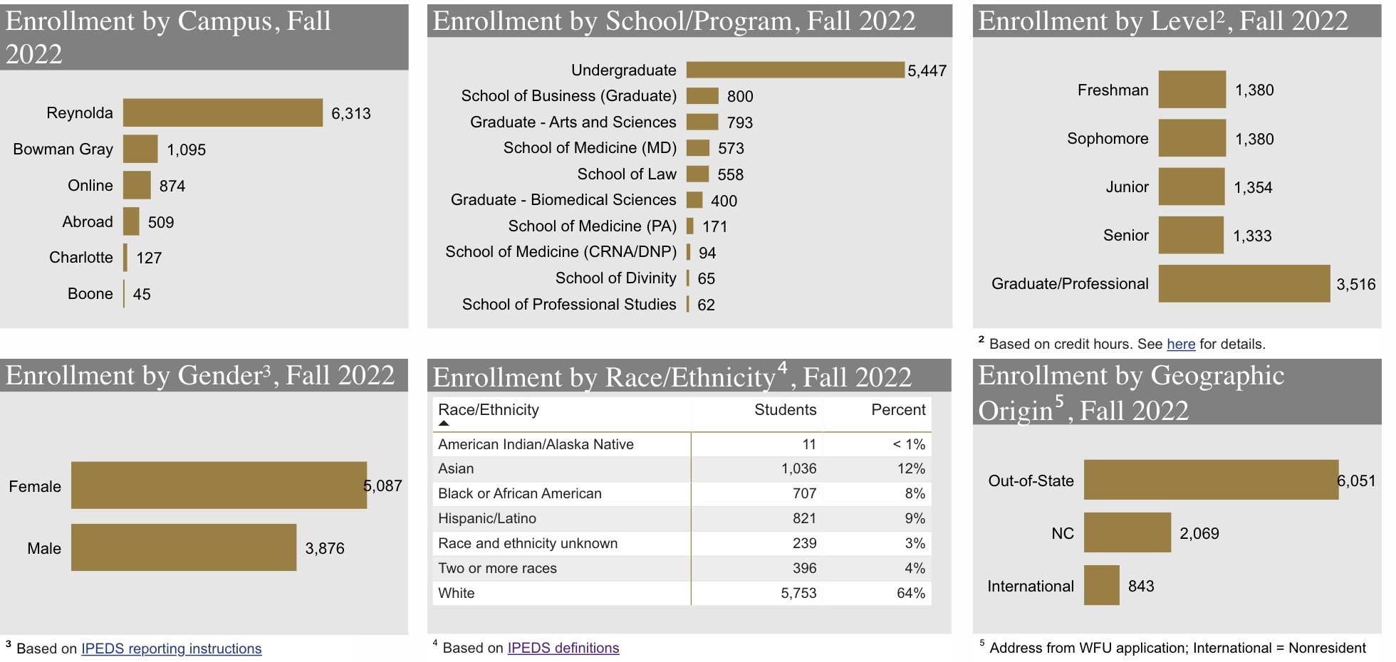

Undergraduate Enrollment (Fall 2022)
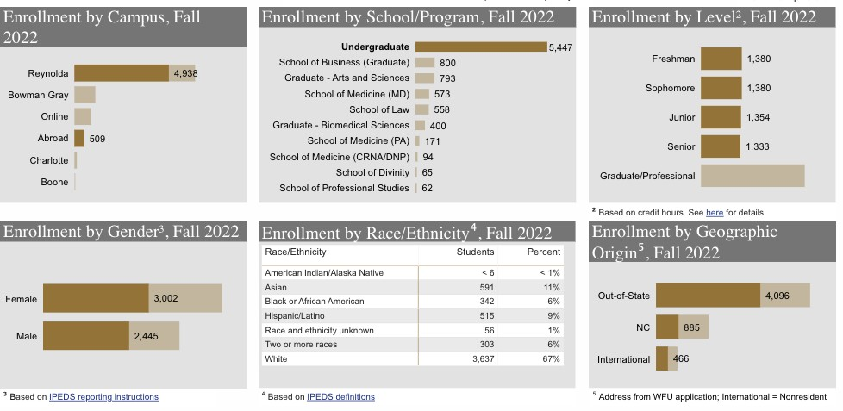

Graduate and Professional School Enrollment (Fall 2022)
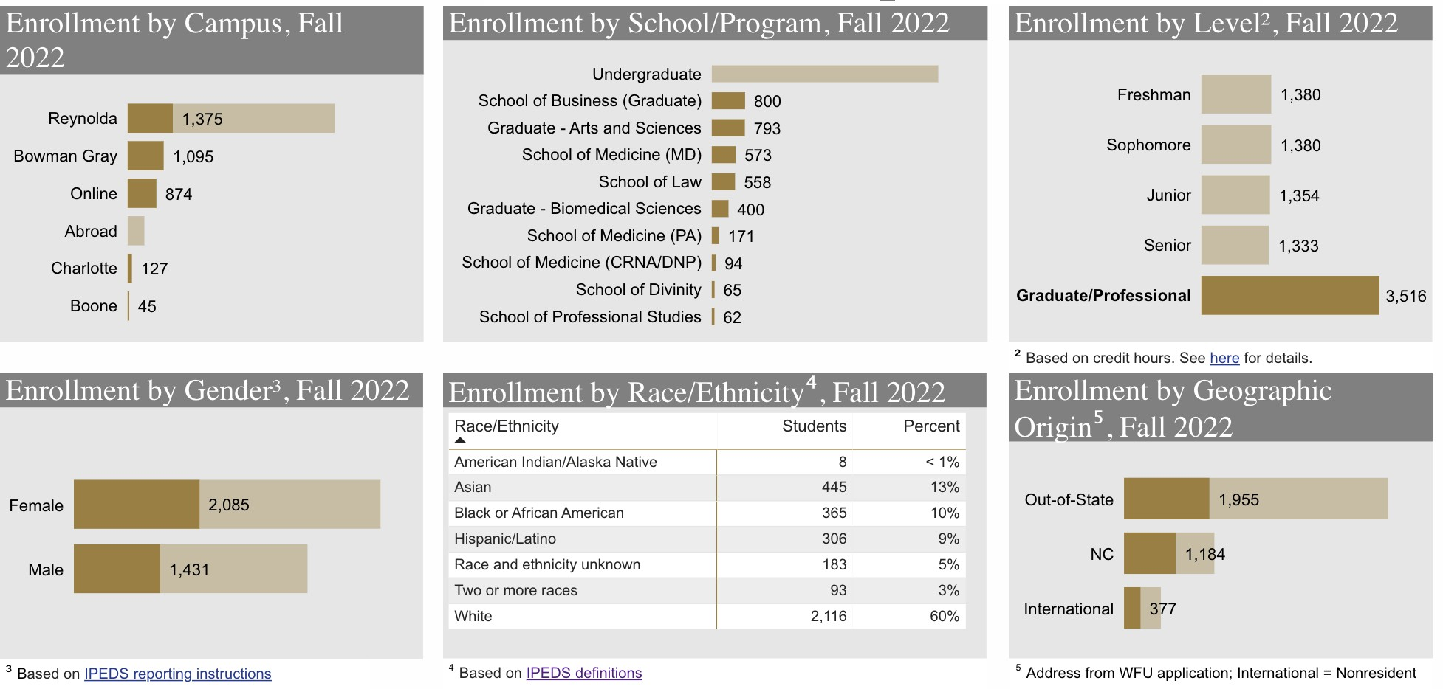

Incoming (new) Undergraduate Student Demographics (Fall 2022)
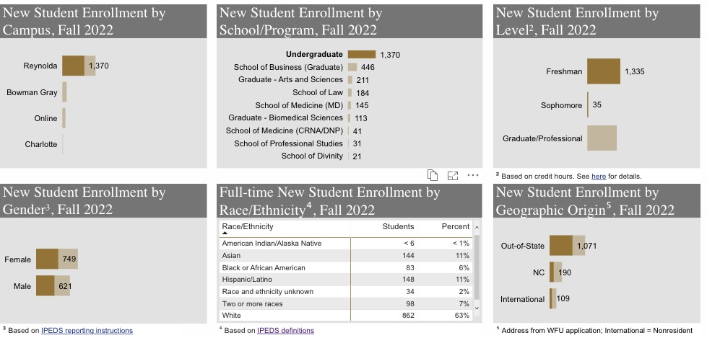

Incoming (new) Graduate and Professional School Student Demographics (Fall 2022)
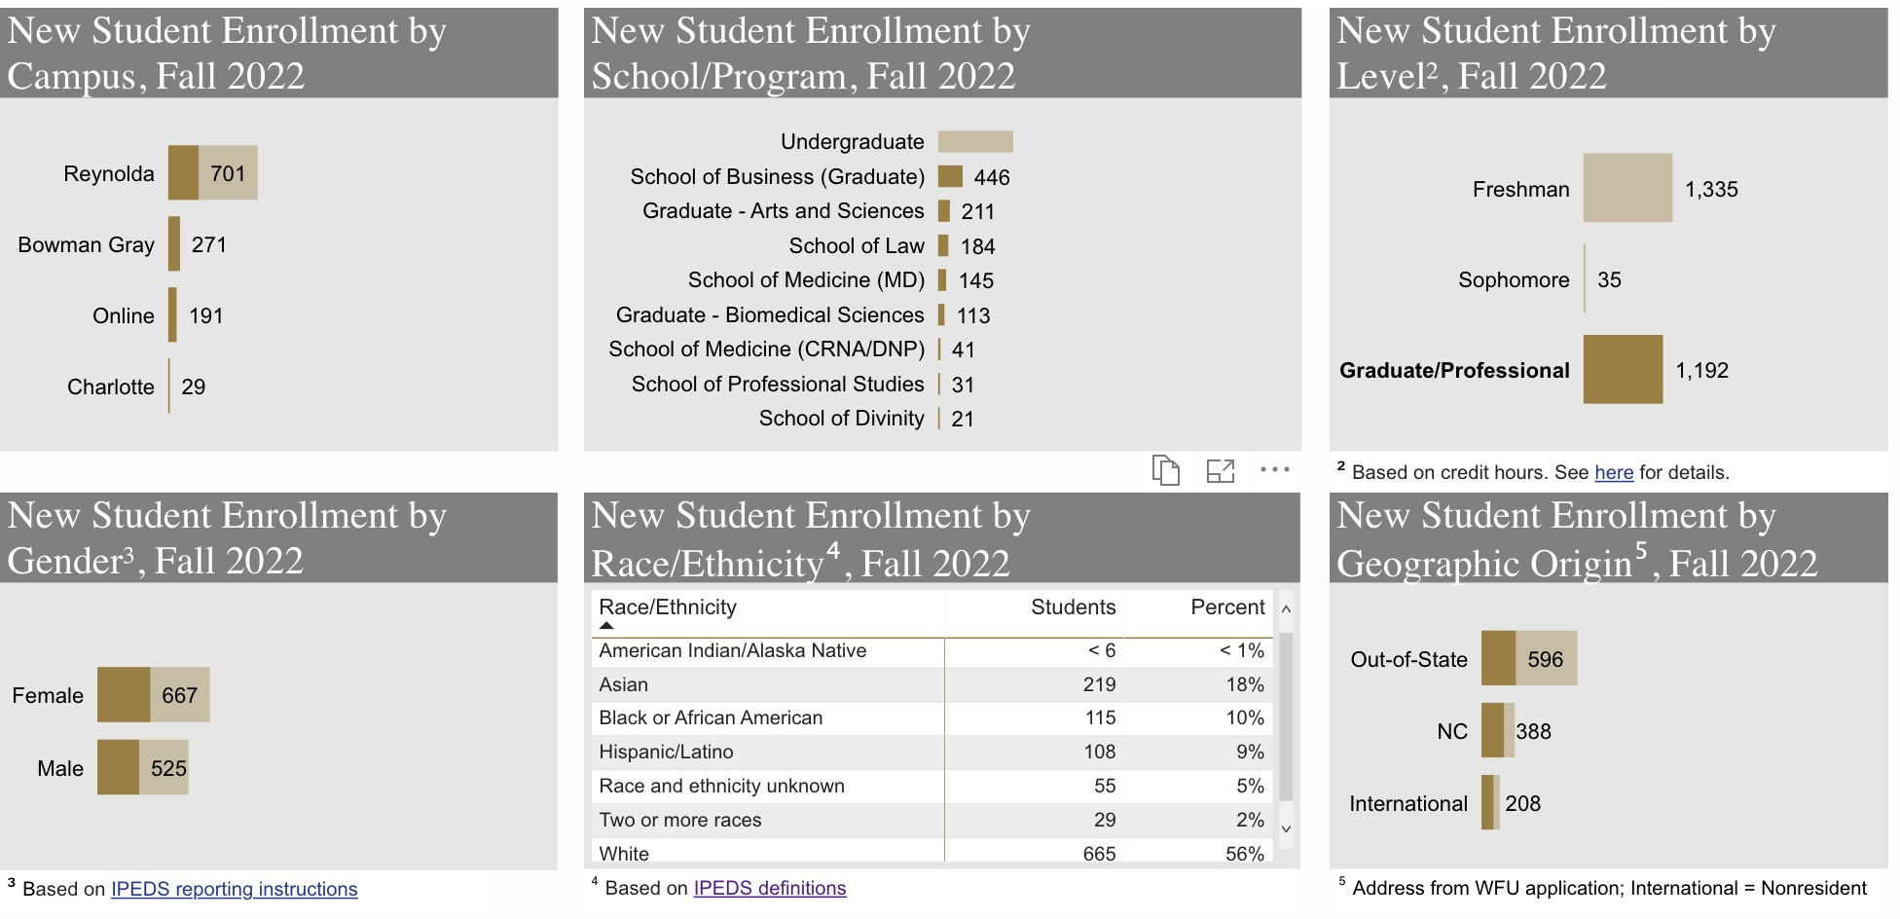

Student Enrollment Trends at Wake Forest University
Changes in Total Enrollment trends from the last few years are reviewed below. By presenting demographic changes over time, we are able to observe how representation has evolved among the student body. In addition, supplementary tables provide more detailed, year-to-year trends by highlighting changes in representation across 3 variables: gender; race and ethnicity; and international status. “Race and ethnicity” data is categorized as “Under- Represented Minority” or “URM.” While the URM category is not disaggregated below, those details can be accessed in the Enrollment section of the WFU Fact Book for specific years.

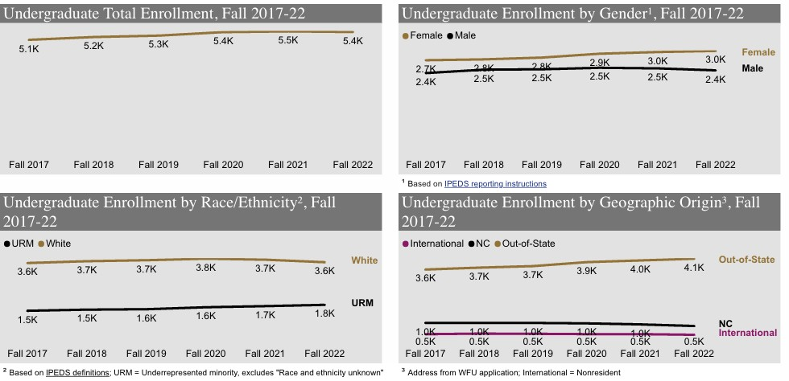
Changes in Enrollment - Undergraduate Programs

Enrollment Changes in Undergraduate Programs by Demographic Factors
Year | Under-Represented Minority | Female | International
FA 17 | 29.2% | 53.6% | 9.7%
FA 18 | 29.5% | 52.8% | 10.0%
FA 19 | 29.5% | 53.2% | 9.7%
FA 20 | 30.3% | 53.7% | 9.2%
FA 21 | 31.0% | 54.3% | 9.1%
FA 22 | 32.2% | 55.1% | 8.6%
*The information reported here adheres to IPEDS data standards. IPEDS currently limits gender to “male” and “female.” As a result, gender trend data does not include individuals who identify as non-binary.

Changes in Enrollment - Graduate/Professional School Programs
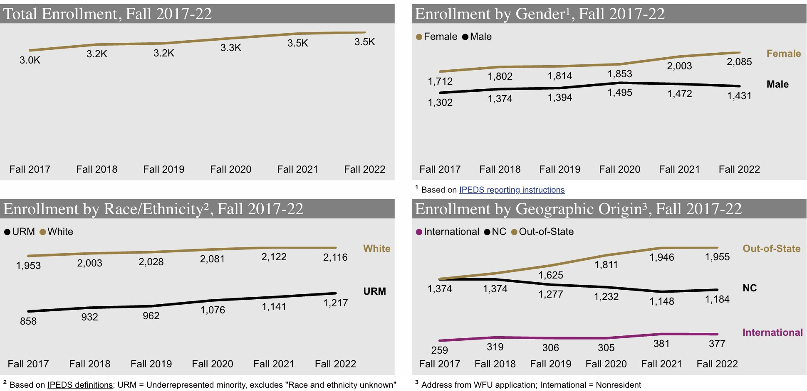

Enrollment Changes in Graduate Programs by Demographic Factors
Year | Under-Represented Minority | Female | International
FA 17 | 28.5% | 56.8% | 8.6%
FA 18 | 29.3% | 56.7% | 10.0%
FA 19 | 30.0% | 56.5% | 9.5%
FA 20 | 32.1% | 55.3% | 9.1%
FA 21 | 32.8% | 57.6% | 11.0%
FA 22 | 34.6% | 59.3% | 9.6%
*The information reported here adheres to IPEDS data standards. IPEDS currently limits gender to “male” and “female.” As a result, gender trend data does not include individuals who identify as non-binary.

