Wake Forest University’s AY 2022-2023

Diversity Status Report
- Faculty and Staff Edition -

Prepared by the Office of Diversity and Inclusion Wake Forest University

Table of Contents
Staff and Faculty Status Report Background 2
Staff and Faculty Diversity at Wake Forest University 3
All Staff (Fall 2022) - Full-time and Part-time 5
Core Reynolda Campus Staff (Fall 2022) - Full-time and Part-time 5
Medical Campus Staff (Fall 2022) - Full-time and Part-time 5
Full-time Staff and Faculty Diversity Trends at Wake Forest University 7
Core Reynolda Campus Staff (Fall 2022) - Full-time 8
Core Reynolda Campus Faculty (Fall 2022) - Full-time 9

Staff and Faculty Status Report Background
This status report is a comprehensive snapshot of Staff and Faculty demographic information that reflects, in part, Wake Forest University’s institutional commitment to transparency and accountability with regards to diversity, equity, and inclusion. This specific report relates to staff and faculty directly employed by Wake Forest University. It is presented to the Office of the President and the Office of the Provost, has been reviewed by the University Diversity, Equity, and Inclusion Council (UDEIC), and it is being made available to all Wake Forest University stakeholders on the ride.wfu.edu website. The information presented here is accurate as of November 1, 2022, when the university took an institutional census of staff and faculty colleagues for academic year 22-23.
The first part of this status report focuses on providing staff demographic data followed by faculty demographic data, including gender, race, ethnicity, and international status. Separate graphs will break down the information based on colleagues affiliated with the core Reynolda campus and those affiliated with the Medical campus in Winston-Salem, NC. The information comes directly from the WFU Fact Book, which can be found on WFU’s Institutional Research (IR) website: ir.wfu.edu/fact-book. Though the tables shared below are “static”, readers of this report may engage with the Fact Book and its “dynamic” user-interface. Academic Year
2021-2022 marked the first year that IR instituted this version of the Fact Book; however, the information assembled by IR in the Fact Book for Staff and Faculty includes data from fall 2018 through fall 2022. (IR does offer pdf versions of Fact Books from Academic Year 1998-1999 through Academic Year 2020-2021.) Furthermore, this new, interactive Fact Book allows users to view and interact with data in a variety of ways using multiple variables (*note that Staff and Faculty data are not reported for cell sizes of five or smaller to protect individual identities).
The second part of this status report looks at demographic trend data for staff and faculty populations across all units affiliated with the core Reynolda campus, as well as the Medical School campus in Winston-Salem and the School of Professional Studies in Charlotte, NC. The information in this section provides a cursory overview of trend data over the past 5 years.
ODI and Wake Forest value the collaborative effort of staff colleagues, faculty, and students to collect, collate, and analyze the large amounts of data and information that made this status report possible. This critical labor significantly expands the university’s shared efforts to increase and improve upon inclusivity and belonging at Wake Forest University.

Staff and Faculty Diversity at Wake Forest University
The following tables are organized by staff and faculty who were directly employed by Wake Forest University on a full-time or part-time basis during fall 2022. As stated above, this information is tabulated annually in the form of an institution-wide census in early November, and it is organized by Institutional Research, with additional input and insight from Information Systems and Human Resources at Wake Forest University. These offices collaborate to take a “snapshot” of the institution, for the purposes of sharing the information with the U.S. Department of Education, through the Integrated Postsecondary Education Data System (IPEDS). Because IPEDS annually reports and publicizes data on faculty and staff (as well as

students) across higher education institutions in the U.S., Wake Forest University uses IPEDS definitions and categories when creating our institutional data sets. The specific “Race,” “Ethnicity,” and “Non-resident” categories used in the tables displayed in this report correspond with guidelines provided by IPEDS and the U.S. Office of Budget and Management (which may be found here: nces.ed.gov/ipeds/report-your-data/race-ethnicity-definitions). Specifically, IPEDS organizes these categories using the following methodology:

- Categories developed in 1997 by the Office of Management and Budget (OMB) that are used to describe groups to which individuals belong, identify with, or belong in the eyes of the community. The categories do not denote scientific definitions of anthropological origins. The designations are used to categorize U.S. citizens, resident aliens, and other eligible non-citizens.
- Individuals are asked to designate ethnicity as:
  - Hispanic or Latino or
  - Not Hispanic or Latino

- Then, individuals are asked to indicate 1 or more races that apply among the following:
  - American Indian or Alaska Native
  - Asian
  - Black or African American
  - Native Hawaiian or Other Pacific Islander
  - White

* Note: Nonresident aliens are to be reported separately in the places provided, rather than in any of the racial/ethnic categories described above.

Though the data below adheres to IPEDS guidelines, readers are also encouraged to visit diversity.wfu.edu/reports for a deeper understanding of representation among students, faculty, and staff at Wake Forest. Starting in fall 2021, IR and ODI collaborated on a report that compares our institutional IPEDS data to a different methodology, called “Maximum Count Methodology,” which can be found here: https://go.wfu.edu/v4z/. The rationale behind the creation of this report is rooted in IPEDS methodologies that: (a) prevent individuals identifying as “Hispanic/Latina/o” from also being accounted for in any other IPEDS racial or ethnic category; and (b) IPEDS categorizes any individual identifying as any combination of multiple races or ethnicities under the singular category of “two or more races.” The “Maximum Count Methodology,” however, allows an individual who (for example) identifies as “Latina and Native American” to be included in the count for both “Latina/o/x; Hispanic” and “Native American.” Taken together, the main advantage to the IPEDS methodology provides the institution with one clear and consistent set of demographic data which can be compared across, for example, peer institutions; however, the main disadvantage to the IPEDS methodology is that individuals who want their intersectionality to be affirmed are denied that opportunity. The university will continue to report our demographic data in this report and in the Fact Book using IPEDS data, as that is what is required by the US Department of Education.

Finally, Wake Forest considers a broad range of staff and faculty identities - and the intersectionality of these identities - when exploring diversity and representation across our institution. While IPEDS requires that the university report gender, ethnicity, race, and whether or not faculty and staff are “residents” or “non-residents,” the university also recognizes colleagues’ possible interests in having their sexual orientation, gender identity, and religious and spiritual beliefs represented, to name but a few additional demographic variables. With regards to these and other demographic variables, Wake Forest is working towards improving the manner in which it gathers and disseminates this information, so as to increase the holistic manner in which we speak to the diversity of our staff and faculty colleagues. As methods for telling a fuller picture improve and emerge, the contents of future Staff and Faculty Diversity Status Reports will expand to include our broad definition of “diversity.”

*When reviewing the graphs below, pay attention to the shading in each graph or image. Dark shades of gold or black indicate the categories represented in a particular graph or image; light shades of tan or gray signify that those categories are not represented in a particular graph or image. More information on how to use, read, and interpret these tables and the Fact Book can be found here: https://ir.wfu.edu/fact-book/user-guide/

All Staff (Fall 2022) - Full-time and Part-time

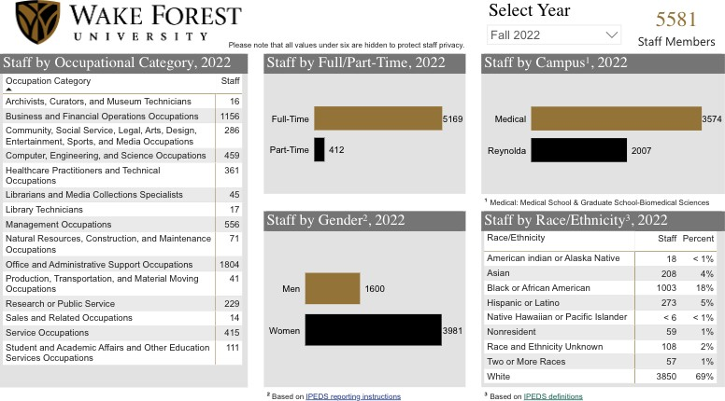

Core Reynolda Campus Staff (Fall 2022) - Full-time and Part-time
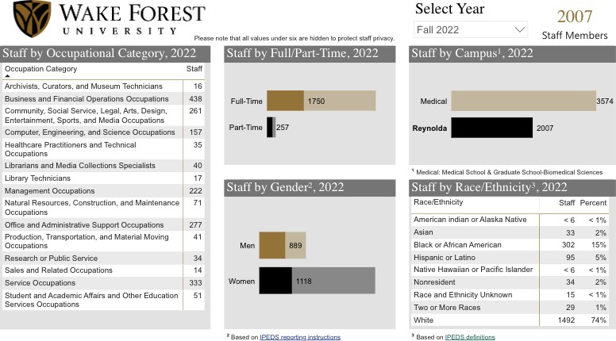

Medical Campus Staff (Fall 2022) - Full-time and Part-time
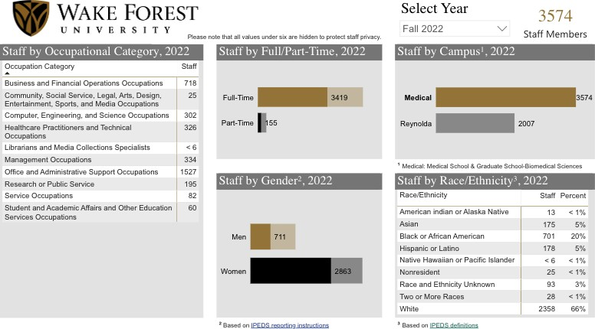

All Faculty (Fall 2022) - Full-time and Part-time
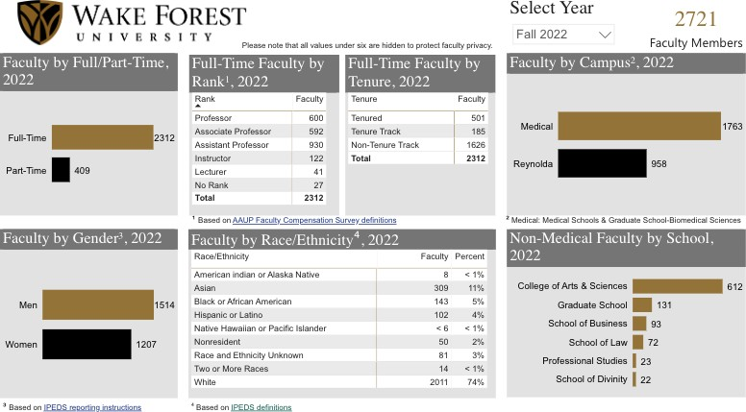
Core Reynolda Campus Faculty (Fall 2022) - Full-time and Part-time
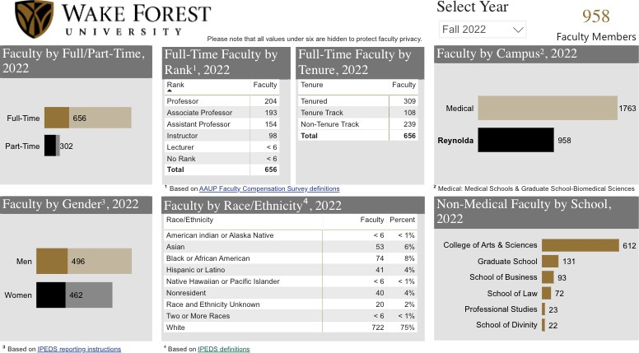

Medical Campus Faculty (Fall 2022) - Full-time and Part-time
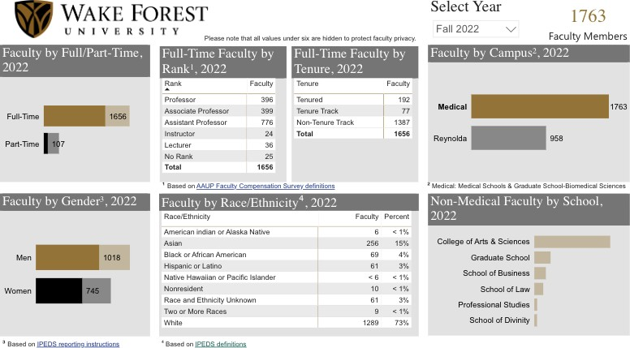

Full-time Staff and Faculty Diversity Trends at Wake Forest University
Wake Forest University colleagues often inquire about year-to-year diversity trends at the institution, particularly for full-time professional staff and faculty. Though there are several ways to answer these questions - and several factors to consider - the questions typically revolve around the diversity of our staff and faculty ranks, and usually the questions are framed or contextualized by increases or decreases in diversity rates for individuals involved in academic or administrative roles at the institution. The following set of graphs and charts provide two sets of data: AY 2022-2023 demographic information for full-time staff and faculty; and demographic information from 2018 through 2022 for 6 different independent variables (arranged by gender; and by ethnicity, race, and whether or not an individual is non-resident of the United States, per IPEDS categories). Note that the Fact Book allows for deeper exploration of additional variables such as Occupational Categories for staff and Title and Rank for Faculty, in addition to exploring those variables in reference to a series of demographic contexts. As with other recommended uses of this report and other Diversity Status Reports (http://ride.wfu.edu/diversity-status-reports/), those interested in addressing additional questions should consult the Fact Book.

Core Reynolda Campus Staff (Fall 2022) - Full-time
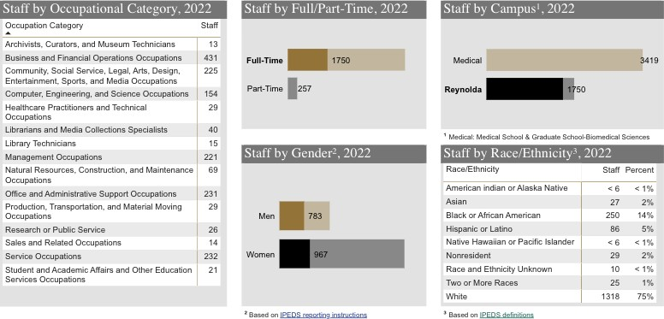

Core Reynolda Campus Staff Core Reynolda Campus Staff
Gender Trends Race/Ethnicity/Residency Trends

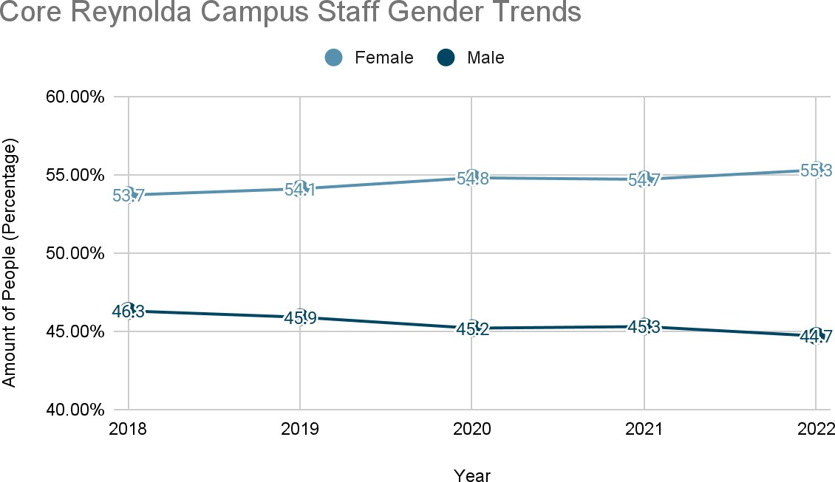
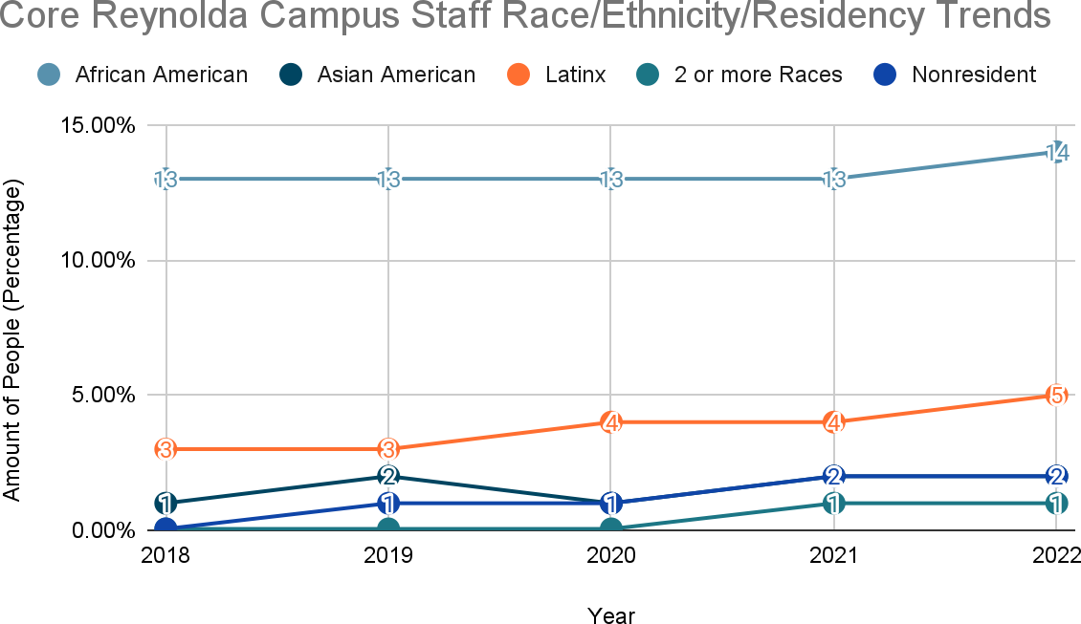

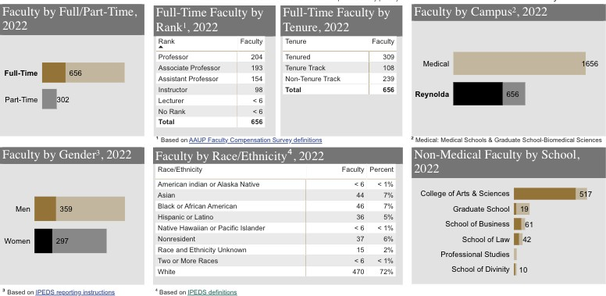
Core Reynolda Campus Faculty (Fall 2022) - Full-time

Core Reynolda Campus Faculty Core Reynolda Campus Faculty
Gender Trends Race/Ethnicity/Residency Trends

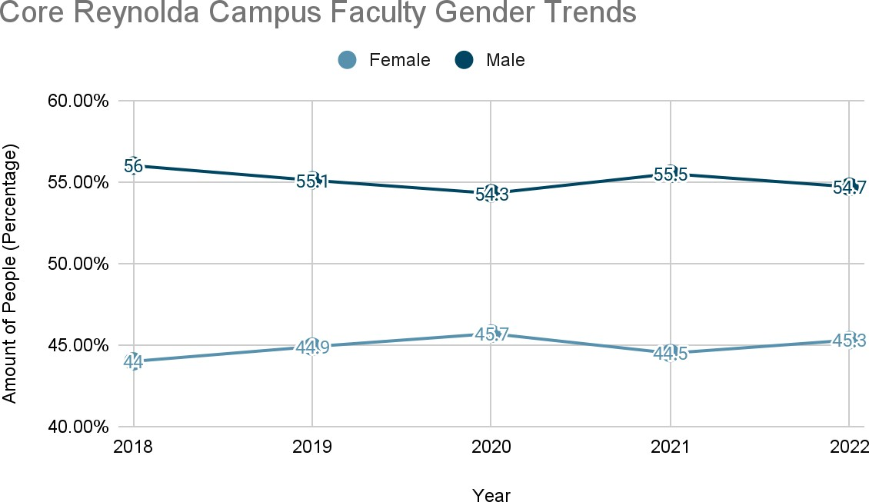
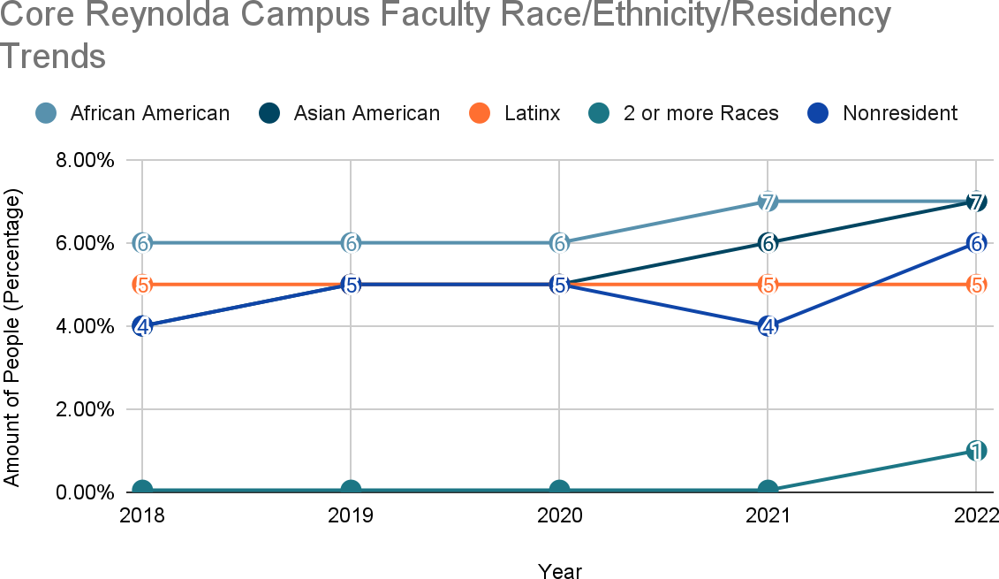

Medical Campus Staff (Fall 2022) - Full-time
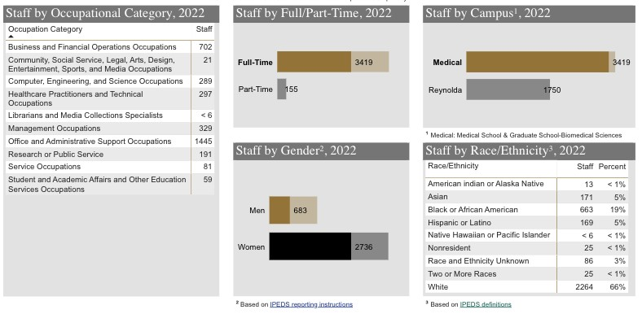

Medical Campus Staff Medical Campus Staff
Gender Trends Race/Ethnicity/Residency Trends

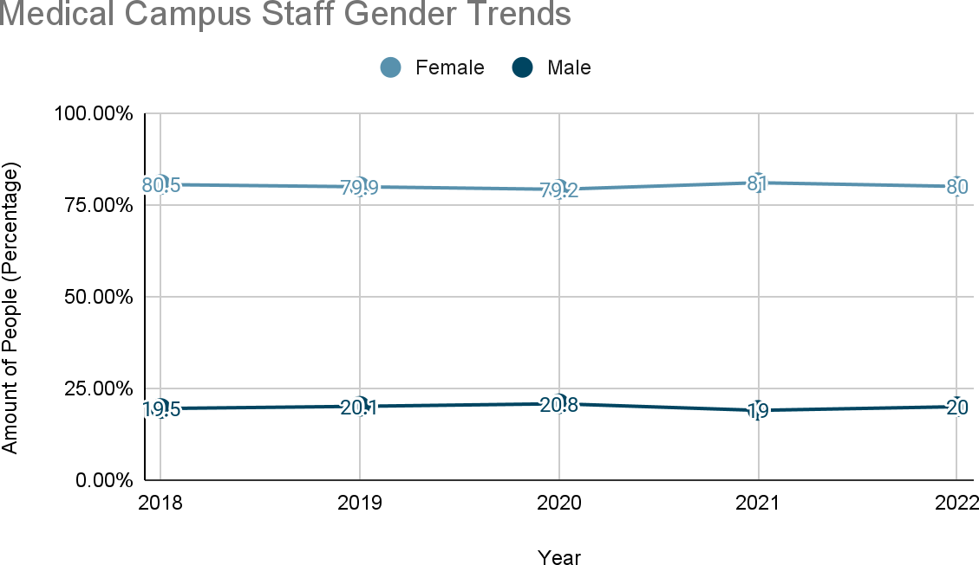
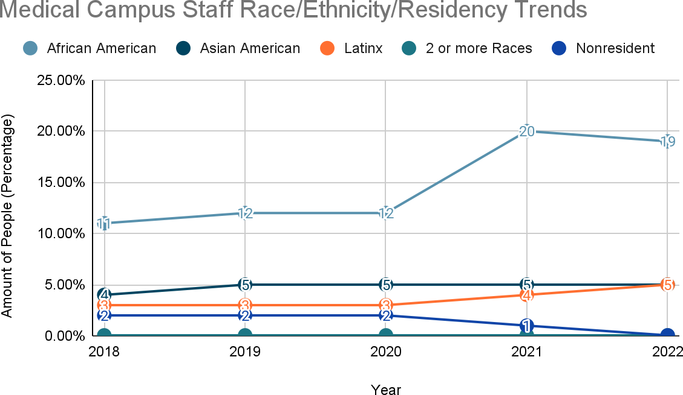

Medical Campus Faculty (Fall 2022) - Full-time
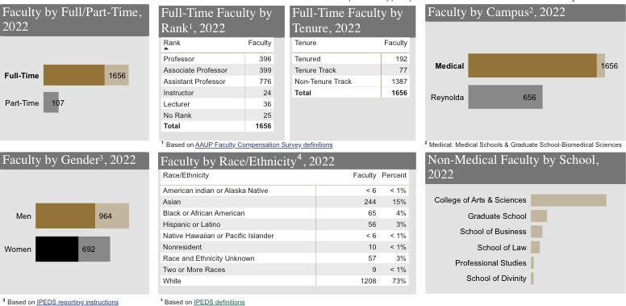

Medical Campus Faculty Medical Campus Faculty
Gender Trends Race/Ethnicity/Residency Trends

