Accountability for Diversity, Equity and Inclusion Leadership
Leaders who support equitable accountability:
- Demonstrate respect for people and their differences
- Understand the benefits of a diverse workforce
- Are trusted and respected by others
- Include and welcome others
- Work to understand the perspectives of others
- Promote opportunities to experience diversity on campus
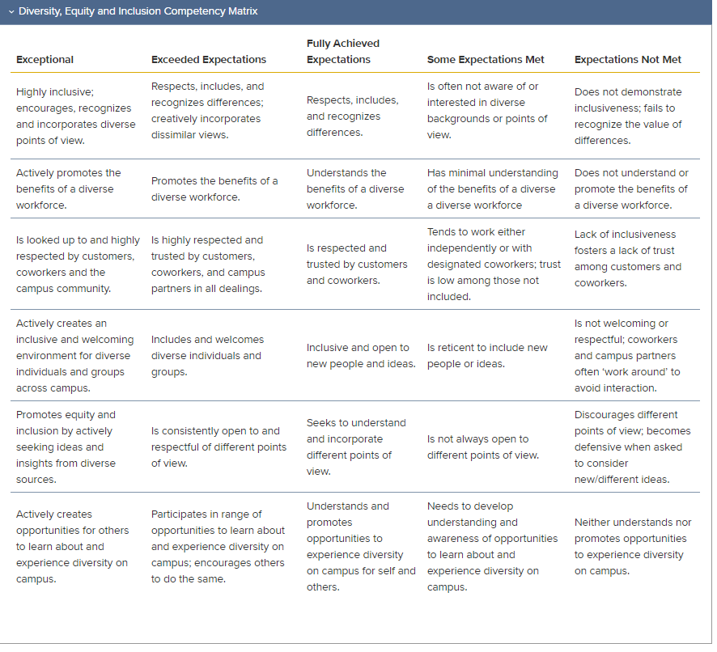
https://hr.ucdavis.edu/performance-appraisals/core-competencies

