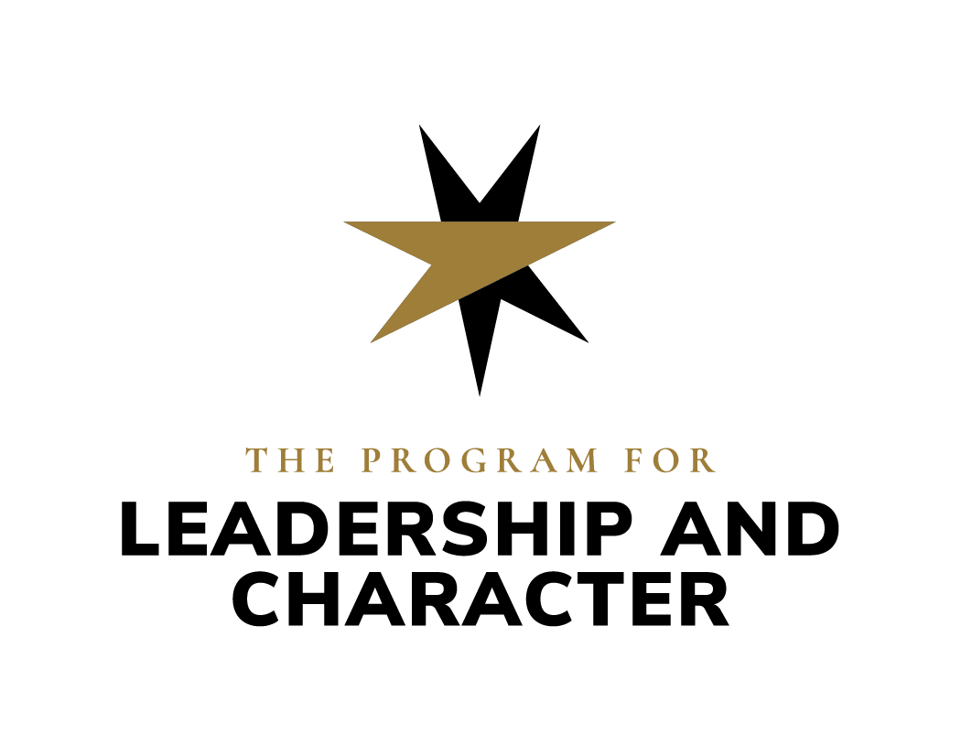
Character in Health Systems

Request for Partner Proposals

Purpose of RFP
From May to August 2024, Wake Forest University’s Program for Leadership and Character will be crafting a request to the Kern Family Foundation (KFF) for a multi-million dollar gift to support the Program’s work in training leaders of character in medical professions. In preparation to write that application, the Program invites partners in the WFU School of Medicine and Advocate Health System to share their ideas for educational projects that promote the character and/or character-based leadership development of the following populations:
- students preparing for medical professions
- medical educators (broadly defined)
- clinicians
- healthcare system leaders.
Through this KFF gift, the Program seeks to supply funds and expertise to partners who will launch pilot projects, revise existing educational programs, and/or implement research and/or assessment on educational programs to better understand their character growth impacts.

Wake Forest University’s Program for Leadership and Character, “inspires, educates, and empowers leaders of character to serve humanity.” Toward this end, the Program develops and disseminates evidence-based educational programming that supports professionals’ growth as leaders of character. The Kern Family Foundation funds the Program for Leadership and Character’s work in medical education.

Questions to be Completed by Partners

Contact Information
- Name(s) and titles of faculty/staff person(s) requesting funds
- Email address of primary contact person

Project Description
- What is your project’s name?
- What is your project’s anticipated total budget?
- Will your project involve hiring full time employees and/or contractors? For which roles?

Project Goals
- Please describe your project’s outputs (ex. A 3-month leadership certificate program for 20 MD students interested in academic medicine, a 2-day retreat for 20 ER Nurse Managers, etc.). Make sure to identify the target population for this educational intervention.
- Please describe your project’s character growth outcomes. In particular, how will you help participants develop compassion for self and others, intellectual humility, respect for diversity, curiosity, teamwork/collaborativeness, belonging, connection to purpose, resilience, and/or trustworthiness in relationships with care team members and patients.
- Please describe your project’s intended impacts on patients, health care teams, society, etc. How might project participants’ character growth address larger social concerns?

***Optional*** Questions
- Please explain briefly (500 words or less) how this project promotes organizational goals of your unit or program.
- Do you have any ideas about how you might assess this program’s success, in terms of the achievement of either its objectives or impacts?
- Are you interested in generating articles, chapters, blogs, TedX Talks or other forms of written or audiovisual work about your project? If so, please describe your ideas.
- Does any scholarship inform the design of your project, especially as it relates to virtue/character development and/or participants’ connection with their sense of purpose? Please list citations of relevant scholarship.
- Please explain briefly (500 words or less) how this scholarship informs the design of your program.
- Please explain briefly (500 words or less) how this project might be economically sustainable within 4-7 years after receiving grant funding or how it might have long lasting system impacts after the project ends.

Timeline
May-August 2024: the Program solicits applications for support from WFU School of Medicine, Advocate Health System, and the Winston-Salem/Forsyth County community, using the questions above.

September-October 2024: the Program works with KFF staff to identify particularly compelling projects.

November 2024-March 2025: the Program works with partners and KFF staff to draft an overall proposal expected to be several million dollars in scope.

Summer 2025: the KFF Board reviews the Program’s proposal and approves none, partial, or full funding of the proposal.

Fall 2025: if the KFF board approves the Program’s proposal, preliminary planning for implementing some projects begins (drafting job descriptions, making introductions among possible collaborators, etc.).

January 2026: if the KFF board approves the Program’s proposal, the Kern Family Foundation transfers funds to the Program, who will then distribute funds to partners. Project collaborations will begin in earnest.

Proposal Instructions
Who may apply? Any employee of the Wake Forest University School of Medicine and Advocate Health System whose job responsibilities include designing, delivering, and/or assessing educational programming to 1) students preparing for medical professions, 2) medical educators (broadly defined), 3) clinicians, and/or 4) healthcare system leaders.

What projects are eligible for funding? For the purposes of this grant, “educational programming” includes: student-facing curricular and extracurricular activities; clinician-facing continuing medical education; leadership and/or professional development projects; equity, diversity and inclusion programs; and/or other interventions which aim to support the character development of clinicians, medical educators, and/or healthcare system leaders. This grant will fund proposals to launch pilot projects, revise existing programs, and/or implement research and/or assessment of new or existing educational programs to better understand their character growth impacts.

How much funding is available? Projects with budgets ranging from $1000 to several million dollars will be considered. Feel free to email Elizabeth Whiting, whitinge@wfu.edu, to schedule a preliminary planning conversation to discuss both scope and content of your anticipated project. The Program hopes to facilitate collaborations among partners with synergistic programming goals and methods.

Deadline for spending grant funds? Grant funding will begin in 2026. The Program welcomes proposals for projects that can be completed within roughly 5 years. For projects with longer timelines, please be prepared to describe your organization’s plans for the financial sustainability of the project over the long term.

Deadline to apply for funds? The Program will accept proposals through December 31, 2024, but priority consideration will be given to applications received by September 1, 2024.

How to apply? For most applications, schedule a preliminary conversation with Elizabeth Whiting, whitinge@wfu.edu. Then answer the questions above and email this form to whitinge@wfu.edu.

What will happen after the application is submitted? Elizabeth Whiting will confirm receipt of most proposals via email within 2 business days. Some applicants will be invited to make a brief presentation of their proposed project to the KFF in fall of 2024. Applicants whose proposals will be included in the Program’s full proposal to the KFF will be notified by February 2025.

What assessment methods or instruments should be used? Assessment methods and instruments widely vary based on project content and scope. The Program’s staff will support in the design of a research and/or assessment strategy any applicant whose proposal is accepted for inclusion in the Program’s larger application to the KFF.

Whom to contact with questions? Send all questions to Elizabeth Whiting, whitinge@wfu.edu.

Selection Criteria
Successful applications will…
- Propose projects that aim to support students’ and/or medical educators’ and/or clinicians’ and/or healthcare leaders’ development of the following: compassion for self and others; intellectual humility; respect for diversity, curiosity; teamwork/collaborativeness; belonging; connection to purpose; resilience; and, ultimately, trustworthiness in relationships with care team members and patients.
- Utilize scholarship that explains what evidence exists to justify the use of a particular project to pursue particular character-development outcomes.
- Demonstrate fiscal responsibility.
- Align proposed project outputs and outcomes with organizational goals of the unit in which the project would take place.
- Align project responsibilities with the job descriptions/scope of work of grant project-affiliated staff.
- Have potential to spark long-term change in the unit or larger health system where the project will be implemented.

