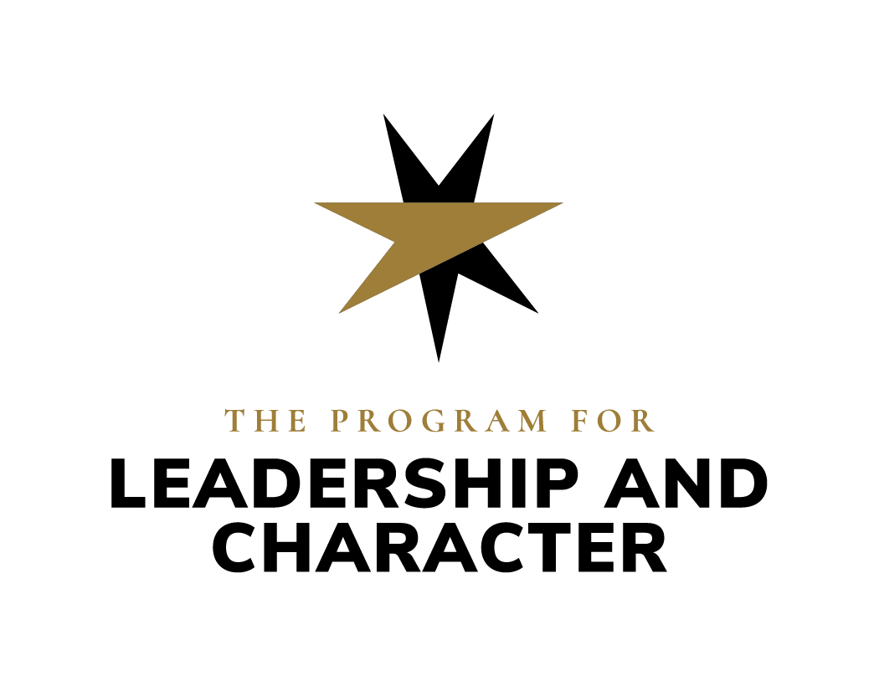
Character in Medicine Grants
Calendar years 2024-2025

Grant Purpose
The Character in Medicine Grant exists to empower employees of the Wake Forest University and Advocate Health System to design, implement, and/or more rigorously assess educational programs that promote participants’ character development, including, for example, by developing compassion for self and others; intellectual humility; respect for diversity; curiosity; teamwork/collaborativeness; belonging; connection to purpose; resilience; and, ultimately, trustworthiness in relationships with care team members and patients. This grant will fund proposals to launch pilot projects, revise existing programs, and/or implement research and/or assessment on programs to better understand their character growth impacts (see italics for character growth examples).

The Character in Medicine Grant is hosted by Wake Forest University’s Program for Leadership and Character, which “inspires, educates, and empowers leaders of character to serve humanity.” Toward this end, the Program develops and disseminates evidence-based educational programming that supports professionals’ growth as leaders of character. The Kern Family Foundation funds the work of the Program for Leadership and Character in medical education.

Questions to be Completed by Applicants

Contact Information
- Name(s) and titles of faculty/staff person(s) requesting funds
- Email address of primary contact person

Project Description
- What is your project’s name?
- Project budget.

Name of Project
Budget Proposal
Items / Services that will be purchased with Grant Funding  (Examples- supplies, speaker fees, travel costs, assessment) | When will this be need to be  purchased by? | Estimated  Amount
 | Subtotal | 0

- Please provide an estimated timeline of key project tasks (ex. curriculum design, data collection and analysis, event planning and advertising, etc.). Please also indicate which staff person(s) will complete each task.

Project Goals
- Please describe your project’s outputs (ex. 6 1-hour workshops to 3rd year MD students, a 2-day retreat for PA faculty).
- Please describe your project’s character growth outcomes. For example, how will you help participants develop compassion for self and others, intellectual humility, respect for diversity, curiosity, teamwork/collaborativeness, belonging, connection to purpose, resilience, belonging, and/or trustworthiness in relationships with care team members and patients?
- Please describe your project’s intended impacts on patients, health care teams, society, etc. How might project participants’ character growth address larger social concerns?

Grantee Responsibilities
- Are you willing to provide an update and/or final report every 6 months, using a template provided by Program staff? The report will include
  - A brief (500 words or less) summary of the project’s activities, outputs and outcomes, any assessment results, including a summary of the post-survey for projects of less than $7,500.
  - A brief reflection on what the project team is learning through the project.
  - Summary of funds spent.

For Applications Requesting $7500+
- Please explain briefly (500 words or less) your strategy for assessing your program’s success with regard to your character growth outcomes. Feel free to draw on resources in this Google folder.
- OPTIONAL: Please give citations to scholarship that informs the design of your project.
- OPTIONAL: Please explain briefly (500 words or less) how this scholarship informs the design of your program, especially as it relates to virtue/character development and/or with participants’ connection with their sense of purpose.

Additional Information Regarding Grant Parameters and Application Instructions
Who may apply? Any employee of the Wake Forest University School of Medicine and/or Advocate Health System whose job responsibilities include designing, delivering, and/or assessing educational programming may apply for a Character in Medicine grant.

What projects are eligible for funding? For the purposes of this grant, “educational programming” includes:
- Student-facing curricular and extracurricular activities
- Clinician continuing medical education
- Care team leadership and/or professional development projects
- Care team justice, equity, diversity and inclusion programs
- Any other intervention which aims to support the care team members’ character development

How much funding is available? This grant funds projects with budgets between $1,000-$30,000. If you have an idea for a project requiring more than $7,500 and/or which will involve a project timeline beyond October 31, 2025, email Elizabeth Whiting, whitinge@wfu.edu, to schedule a preliminary planning conversation.

Deadline for spending grant funds? Grant funds must be spent by October 31, 2025.

Deadline to apply for funds? Grant applications will be accepted on a rolling basis between May 2024 and August 2025.

How to apply? For projects over $7,500, schedule a preliminary conversation with Elizabeth Whiting, whitinge@wfu.edu, and/or Lauren Iley-Spear, ileyspl@wfu.edu. (Grantees seeking less than $7,500 are welcome but not required to hold a preliminary conversation). Then fill out the application questions above and email that document to whitinge@wfu.edu & ileyspl@wfu.edu.

What will happen after the application is submitted? Program for Leadership and Character staff will confirm receipt via email within 2 business days and follow up within 2 weeks with any questions, supporting document requests, and next steps.

What are grantees’ responsibilities after receiving the funds? See “Grantee Responsibilities” section above.

What assessment methods or instruments should be used? For projects under $7,500, the Program for Leadership and Character will provide a brief post-event assessment survey for project participants. For projects over $7,500, the project budget should include the costs of assessment data collection and analysis (including hiring an independent contractor, if necessary). Program for Leadership and Character staff are available for consultation in the design of assessment strategies. Applicants should also feel free to draw on this folder for general guidance and example instruments for assessment in character education.

Whom to contact with questions? Send all questions to Elizabeth Whiting, whitinge@wfu.edu and/or Lauren Iley-Spear, ileyspl@wfu.edu.

Selection Criteria
Successful applications will…
- Aim to support students and/or clinicians’ character growth in one or more of the following areas: compassion for self and others; intellectual humility, respect for diversity; curiosity; teamwork/collaborativeness; belonging; connection to purpose; resilience; belonging,; and/or trustworthiness in relationships with care team members and patients.
- Have potential to encourage the continued use of educational practices that support character growth in the unit where the project will be implemented.
- If possible, utilize scholarship that explains what evidence exists to justify the use of this particular project to pursue these particular character growth outcomes.
- Demonstrate fiscal responsibility, providing a clear and reasonable budget.
- Align proposed project goals with organizational goals of the unit in which the project would take place.
- Align project responsibilities with the job descriptions/scope of work of grant project-affiliated staff.
- Be logistically feasible within the funding and scheduling parameters of the grant ($1000-$30,000 to be spent on non-salary project costs before October 31, 2025).

