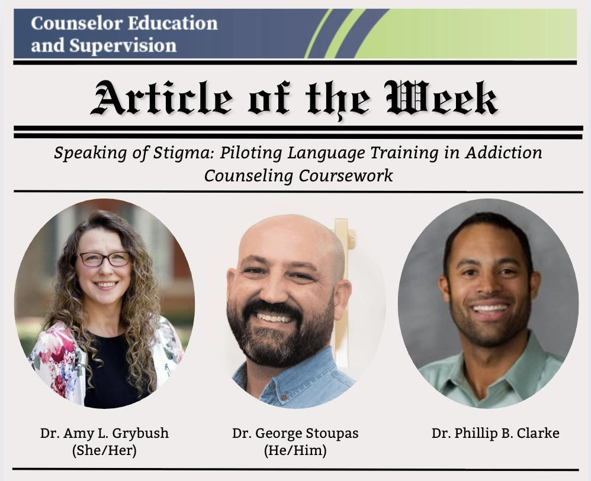
CE&S: Article of the Week

Meet the Authors
- Amy L. Grybush (she/her), Assistant Professor, Wake Forest University
- George Stoupas (he/him), Associate Teaching Professor, Wake Forest University
- Phillip B. Clarke, Associate Teaching Professor, Wake Forest University

Abstract
This pilot study examined counselor-in-training (CIT) attitudes and awareness regarding stigma and stigmatizing language aimed at those with substance use disorders before and after an author-developed educational intervention. Results indicated this intervention positively
impacted CIT awareness and attitudes and their ability to identify and change stigmatizing language. Implications are discussed.

Words from the Authors
Stigma is pervasive in the SUD treatment field, and counselors are not immune to unwittingly
perpetuating that stigma through the words they use. We know a lot about the harm stigmatizing

language can cause, and by developing and testing educational interventions, we hope to prepare future counselors to recognize and dismantle stigma, fostering more compassionate, evidence-
based care.

Read More
Grybush, A. L., Stoupas, G., & Clarke, P. B. (2025). Speaking of stigma: Piloting language training in addiction counseling coursework. Counselor Education and Supervision, 64(3), 321–330. https://doi.org/10.1002/ceas.12344

