ELECTIONS: FALL 2020

ELECTIONS COMMITTEE

Miles Middleton Co-Chair, SG President
Ally Swartzberg Co-Chair, SG Speaker of the House
Caroline Walker SG Secretary
Victoria Parker SG Treasurer
Drew Skilton SG Chief of Staff
Ethan Wearner Judiciary Co-Chair
Sebastiano Tibolla Judiciary Co-Chair

IMPORTANT DATES

Tuesday, September 8th ∙ Elections Packet is released
Tuesday, September 15th 8:00 PM ∙Candidates’ Meeting with Packet
Tuesday, September 22nd^{th} 12:00 PM ∙Polls Open on the LINK
5:00 PM ∙Campaign Budgets Due
Wednesday, September 23rd 11:59 AM ∙Polls Close Online
5:00 PM ∙Results Posted, via Email

Statement Regarding Elections
Student Government elections are a sanctified process for the student body of Wake Forest University, and it is vital that they remain so. It is the goal of the Elections Committee to ensure that the elections are fair and equitable, enforce all campaign rules, and investigate and punish all campaign violations.
CAMPAIGN REGULATIONS
General Rules
1. Each candidate is responsible for a FAIR and HONEST campaign. Violation of this principle shall be seen as a violation of the fair and honest campaign guidelines set forth in the Student Government Constitution, and may be punishable by disqualification.
2. Each candidate is responsible for all aspects of his/her campaign. This means that the candidate bears the ultimate responsibility for both his/her actions and the actions of campaign staff members working on behalf of his/her campaign, who are subject to all regulations the candidate is. Campaigning is defined as any use of oral or written communication to explicitly endorse the election of a candidate to an elected office. A Campaign Staff Member is defined as anyone who campaigns on behalf of any particular candidate with the candidate’s knowledge. All campaign staff members must sign the Campaign Staff Pledge saying that they will abide by all Elections Guidelines in order to be considered official staff members and to receive e-mail communication from the candidate. In the event that a staff member is abroad, a digital signature will suffice. In the event that an acquaintance of the candidate who is not on the candidate’s official campaign staff is campaigning for the candidate with the candidate’s knowledge, for the purposes of enforcing campaign violations that acquaintance is considered a member of the campaign staff. The one exception to this comes in the event that the candidate has explicitly told said acquaintance to desist his campaigning activity. No unofficial campaign staff member is eligible to receive emails from the candidate, even if recognized by the Election Committee as a de facto staff member.
3. A write-in candidate, if conducting a campaign, will be subject to the same regulations as the declared candidates. The Wake Forest community is encouraged to report campaign infractions on the part of write-in candidates and their de facto staff as they would any declared candidate. Write-in candidates will only have to answer for these alleged violations in the event that they receive enough votes to win or enter a runoff election, at which time the violations must be dealt with by the Elections Committee before the results of that race may be verified. Any winning write-in candidate will be expected to provide an estimated campaign budget. Ignorance on the part of a write-in candidate (or any other candidate) of the campaign regulations is not an excuse for violating the rules set forth by the Elections Committee.
4. Negative campaigning is STRICTLY PROHIBITED. As defined in Statute 1, Section 3: Negative campaigning will not be tolerated by the Election Committee and any negative campaigning will result in immediate and appropriate sanctions. Negative campaigning is defined as any personal attack (in electronic format, speech, or writing) on a candidate—i.e., ad hominem attacks. A personal attack is defined as any libelous, slanderous, or otherwise defamatory claim made against a candidate’s character or person.
Campaigning against a candidate’s platform or a given policy is NOT negative campaigning and is acceptable. All negative campaigning is prohibited. Examples of negative campaigning includes, but are not limited to, addressing a candidate in a derogatory manner, making an attack on an opponent’s character, releasing confidential information regarding an opponent, or producing any factual misrepresentations of a candidate.
5. Candidates and their respective campaign staff are not allowed to publish any material which is deemed to be false and can be sanctioned. Any member of the Wake Forest community has the right to challenge the validity of any statement published on the candidates platform and verbal or digital statements.
6. Signatures for petition to run cannot be collected until two weeks prior to the candidate’s meeting (9/15/20).
7. All executive candidates are required to attend the candidates debate, unless special circumstances arise.
8. The Golden Rule of Campaigning: Ask before you act! Reach out to a member of the Elections Committee if you have any questions.
REGULATIONS REGARDING ELECTRONIC MEDIA.
1. EMAIL. Campaigning via listservs or emails sent to multiple recipients (including CC and BCC) is strictly prohibited. Candidates may send emails regarding campaigns if and only if all recipients are members of the campaign or official endorsers of the candidate.
2. SMS AND OTHER TEXT MESSAGES. The creation of any new GroupMe, SMS, and/or other group-chats through text message-based platforms (including but not limited to WeChat, iMessage, etc.) used for the purpose of campaigning is prohibited. Chats created to communicate with campaign staff are the sole exception to this rule.
3. FACEBOOK. Candidates may use their personal pages, campaign pages, and personal pages of the candidate’s campaign staff. Candidates may use the official “Class of” pages. Candidates may not send campaign-related Facebook messages to multiple non- staff recipients. Facebook advertising is permitted.
4. SNAPCHAT. Candidates may post campaign-related Snapchat stories. Candidates may not send campaign-related personal Snapchats or use the chat function for campaigning except for communicating with members of the campaign staff. Candidates may create Snapchat filters, subject to financial regulations.
5. TWITTER. Candidates may tweet from personal accounts, campaign staff members’ personal accounts, and campaign accounts. Candidates may not directly message multiple voters. Only campaign staff and the candidate may be tagged in tweets.
6. INSTAGRAM. Candidates may post photos from their personal accounts, campaign staff members’ personal accounts, or campaign accounts. Usage of the direct message function to multiple recipients is prohibited. Only campaign staff and the candidate may be tagged in photos.
REGULATIONS REGARDING BROADCAST MEDIA.
1. RADIO. Candidates may appear on Wake Radio programs. A Wake Radio host wishing to hold an on-air debate must include the Elections Committee in the planning of the event.
2. TV. Candidates may appear on Wake TV shows. The Elections Committee must be included in the planning of any televised debates.
REGULATIONS REGARDING PRINT MEDIA.
1. Candidates shall adhere to the University posting and sidewalk policy, available at:
http://rlh.wfu.edu/news/campus-posting-pol icy/
Regulations Regarding Endorsements and Staff
1. An endorsement shall be defined as a written expression of support by an individual for the candidate published either by the candidate, campaign staff, or endorser on behalf of the campaign team.The endorser must notify, either in writing or electronic mail, the Elections Committee of his/her/their intent to endorse before the endorsement may be published. Endorsements may be sought no earlier than the first day of campaigning, and must be submitted to the Elections Committee for approval no later than twenty-four hours before the polls open on Tuesday, September 22nd, 2020.
2. Any endorsement must include a disclaimer that is reasonably legible and in plain view of the endorsement stating the following: "The views and opinions expressed in this endorsement are those of the endorser and candidate alone and do not necessarily reflect the position or policy of any organization that either party is affiliated with or a member of."
3. Campaign staff offers may be made no earlier than two weeks before Election Day.
4. A non-campaign staff member posting a candidate's campaign graphics on social media does not count as an endorsement and therefore does not need to follow endorsement regulations.
REGULATIONS REGARDING CAMPAIGN FINANCE.
1. MAXIMUMS. a. Executive Offices: $125, In a runoff, candidates may spend an additional $30, plus what remains of the original budget. b. Senators: $40. In a runoff, candidates may spend an additional $10, plus what remains of the original budget. c. Campaign budgets MUST NOT exceed these limits.
2. ACCOUNTING. All gifts, donations and rented items, if used for campaign purposes, should be listed with an estimated dollar value if a receipt cannot be obtained. The Elections Committee reserves the right to question these estimates based on reasonable market values. Candidates are expected to notify the Elections Committee ahead of time if they will be accepting any gifts or donations, and may only use them if other candidates could reasonably be expected to be able to rent/borrow at a similar price (equal-access philosophy). a. Sales tax is considered an expenditure. b. Shipping is not considered an expenditure. c. All printing will be valued at a minimum of the Benson Copy Center same-day price. If an outside resource for printing is used, the candidate will use the higher of the two for budgeting purposes. d. Website domain purchasing fees are considered an expenditure. e. Extra bandwidth fees are not considered an expenditure. f. Unpaid human labor is not considered an expenditure; however, paid labor must be included in the budget. g. Failure to submit an accurate budget will be grounds for disqualification.
3. FUNDING ASSISTANCE . Student Government wants to ensure that all students have an equal ability to run for office in order to accurately represent the student body. If you would like to submit a request for funding assistance, please email the Student Government Advisor Tim Wilkinson at wilkints@wfu.edu as soon as possible. Please keep in mind that these requests are confidential and must be reviewed by the Office of Financial Aid. a. In order to receive funding assistance, the candidate must be DB Card certified. Please visit: DB Card Training to take the course prior to the candidates meeting.
REGULATIONS REGARDING ELECTION DAY
1. Candidates may not provide the computer on which voters vote.
2. Candidates and campaign staff must be 15 feet away from a student who is voting.
3. In the event of the construction of voting stations, candidates and campaign staff are required to maintain a distance of at least 15 feet.
4. All regulations regarding electronic and print media apply.
SANCTIONS
There shall be three classes of infractions for actions by candidates against the regulations and requirements in this packet. All candidates are allowed to actively campaign until the Elections Committee reaches a decision on the presented infraction. However, the Election Committee reserves the right to suspend this rule in the case of a severe infraction. Any class sanction could result in disqualification from the election pending approval by the faculty advisor, depending upon the severity of the infraction. The incident may also be forwarded to the Office of Student Conduct for a potential honor code hearing.
Class 1 Offense: A fine of $25, to be subtracted from the candidate’s budget. A suspension of active campaign privileges for a set period of time of at least 1 hours and not exceeding 6 hours.
Class 2 Offense: A suspension of active campaign privileges for a set period of time of at least 6 hours and not exceeding 24 hours.
Class 3 Offense: Subject to disqualification from the election pending approval by the faculty advisor.
The Elections Committee reserves the right to add on community service hours or substitute community service hours for a portion of or for the total of a fine for any sanction, to be considered on a case-by- case basis. The rate of substitution will be applied equally for all candidates. Any candidate who fails to pay fines will be prohibited from taking office or running for a subsequent Student Government office.
ELECTIONS COMMITTEE
1. The Elections Committee has the ultimate authority in all matters concerning elections procedures, violations, and sanctions.
2. The power to disqualify a candidate from the election rests solely with the Elections Committee, pending faculty advisor approval.
3. Infractions may be reported to the Elections Committee by any member of the Wake Forest community. The person who witnesses the infraction must report it to the Elections Committee within twenty-four hours of witnessing the incident.
The following guidelines are used to verify election infraction complaints:
1. All complaints should be submitted to the Elections Committee within twenty-four hours of the offense; if the infraction is reported on Election Day it must be reported before midnight and must provide proof of clear and convincing evidence.
2. The person(s) that witness(es) the offence must be the only person(s) submitting the report of the campaign infraction.
3. Before the Elections Committee makes a final ruling on a campaign infraction, it will hear from the accused candidate and the person(s) submitting the complaint.
4. If someone on the Elections Committee witnesses a campaign infraction it must be reported, but the member must abstain from voting on that particular infraction.”
5. Elections Committee rulings must reach a two-thirds majority vote.

♦ ELECTIONS: Fall 2020 ♦ Candidate Information Packet ♦
WAKE FOREST UNIVERSITY
Student Government Elections
Campaign Budget

Name:

· No Senate candidate shall spend more than $40.
· All gifts, donations, and other things received free of charge must be included in the budget with an estimated dollar value.

· All receipts should be attached to this document.

· The failure to submit an accurate budget by the deadline indicated below may result
in disqualification from the election.

All Campaign Budget documents are due in the Secretary via email (walkct18@wfu.edu) by 5:00 pm on Tuesday, September 22nd, 2020.

ITEM (Please attach receipt) COST

TOTAL EXPENDITURE: $

My signature below certifies that all statements made on this document are complete and accurate. I understand that any misleading or incorrect statements or omissions may render my candidacy void, and, if I am elected to the position, may be cause for immediate dismissal.

SIGNATURE: DATE:

♦ ELECTIONS: Fall 2020 ♦ Candidate Information Packet ♦

WAKE FOREST UNIVERSITY
Student Government Elections
Pledge to Abide by Campaign Regulations

NAME:
RESIDENCE HALL:
This document is due to the Secretary via email (walkct18@wfu.edu) by Tuesday, September 15th, 2020.

On my honor, I pledge to abide by all elections guidelines in the above document. I will adequately inform my campaign staff of the rules and requirements, and to the best of my ability ensure that they follow them as well. I will submit an accurate budget by 5PM on Election Day. I understand that if I fail to abide by these guidelines myself or through my campaign staff that I risk disqualification. I understand that ignorance of the contents of this document on my part or that of my campaign staff is not an excuse for violating the rules.

Signature: __________________________________

The space below may be used to register campaign staff. Please have each member print and sign his/her/their name. Any campaign staff members who join after the submission of this document must be independently registered with the Elections Committee.

♦ ELECTIONS: Fall 2020 ♦ Candidate Information Packet ♦
WAKE FOREST UNIVERSITY
Student Government Elections
Senator Petition

The Student Government Senate is the centerpiece of Student Government. It is directly responsible for representing the study body with regard to campus issues. The Senate consists of approximately 50 senators, with one senator per 100 students in each class. Resident students are elected by students from the respective classes.

Please complete the petition here (hyperlink) via The Link. The completed form is due Tuesday, September 15th. All candidates are required to attend a mandatory candidates meeting on Zoom (link to follow) at 8 pm on Tuesday, September 15th. The election will be held on Tuesday, September 22nd.

Absolutely no campaigning of any sort is allowed until after the candidates meeting.

If you have any questions, please contact a member of the Elections Committee.

♦ ELECTIONS: Fall 2020♦ Candidate Information Packet ♦
WAKE FOREST UNIVERSITY
Student Government Elections
Senator Petition

YOU MAY NOT POST YOUR INTENTION TO RUN OR YOUR GOOGLE FORM TO GATHER SIGNATURES, THAT WOULD BE CONSIDERED CAMPAIGNING! YOU MAY ONLY CAMPAIGN OFFICIALLY AFTER THE CANDIDATES MEETING, TUESDAY, SEPTEMBER 15th.

Signature Collection
Candidates will be required to collect the appropriate number of signatures for the position they’re running for virtually and submit the link of the Google Form on the LINK. The form on the LINK will also be your Candidate form/interest for the Election Committee’s accountability standard.
To collect virtual signatures, candidates must use a google form using the template outlined below. Fill in your name and the position you wish to run for. Since you are running for a senator position, you will need to collect 20 signatures. All 20 of these signatures must be from students in your class. Aside from your name and residence hall, do not modify any other language.
You must also make Miles Middleton (middmh17@wfu.edu) and Ally Swartzberg (swaral18@wfu.edu) collaborators, so that the elections committee can verify the signatures. You can do this by clicking the three dots beside the send button. Click Add Collaborators, then add as a collaborator.
Lastly, you must set the form to automatically collect email addresses. This is to ensure that individuals are personally signing their names. To do this, click Send and check the box that says “Automatically collect a respondent’s Wake Forest University email address.” Be sure to do this before sharing the link.
Upon completion, submit your signatures formally here (hyperlink). This petition must be filled out in its entirety and submitted by Tuesday, September 15th at 8pm. Your candidacy for senate will not be considered until this petition has been received by the elections committee through the LINK.

Template for Signature Collection

Student Government Elections Signature Collection

WAKE FOREST UNIVERSITY
Student Government Elections First Year Senator Petition
Name: *insert name* Residence Hall: *insert residence hall*

I wish to run for Student Government Senator. This petition merely places my name on the ballot, and you are in no way obligated to vote for me by signing it. I must obtain 20 signatures from students of my class.

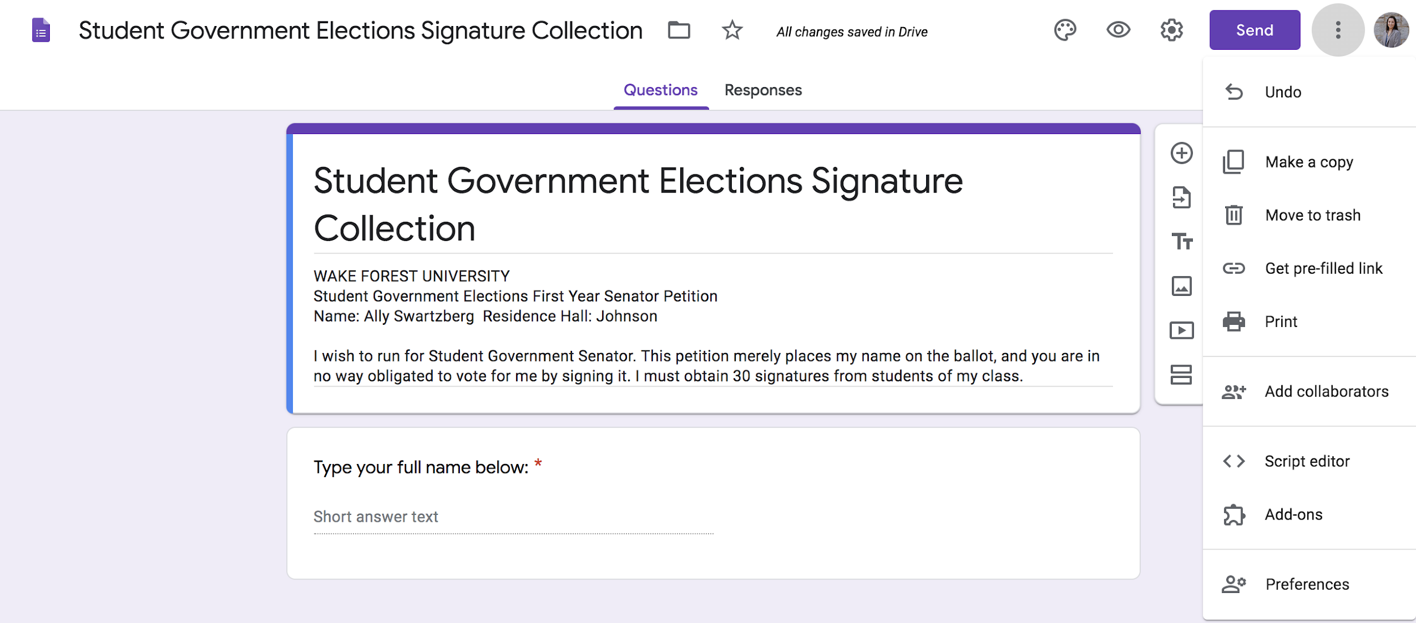
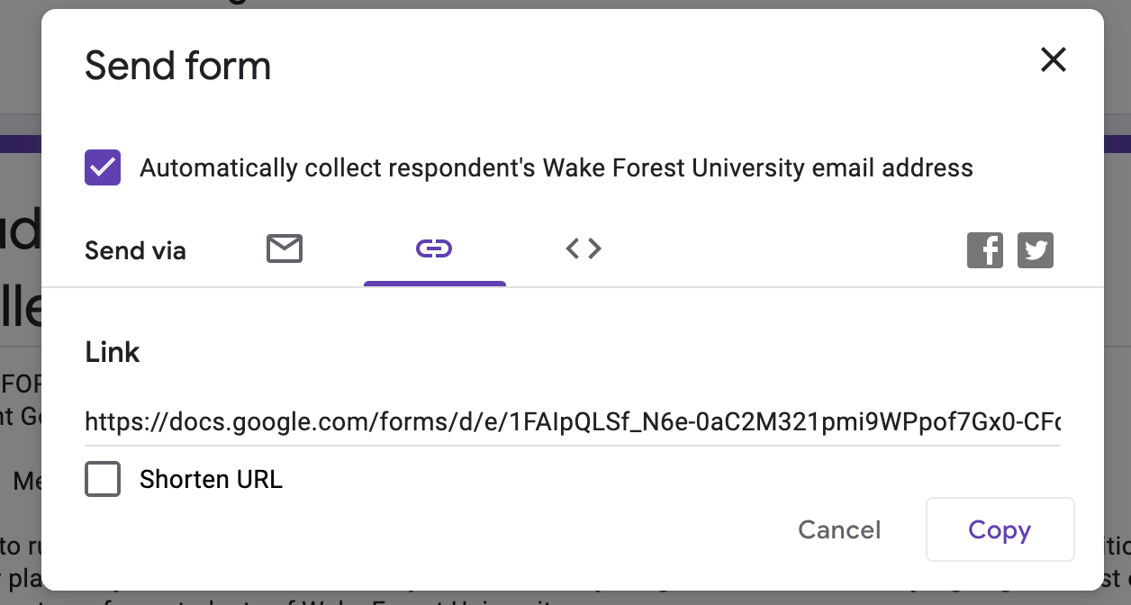

♦ ELECTIONS: Fall 2020 ♦ Candidate Information Packet ♦

