Understanding Cross-Cultural Differences in Engagement

What is Nonverbal Communication?

Nonverbal communication describes the way people send and receive information to each other beyond words.

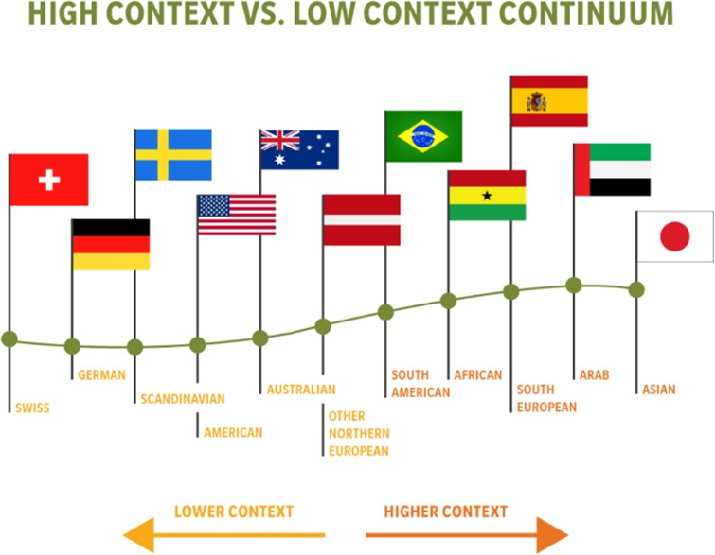
High-Context vs. Low-Context Cultures
Figure 1: Country flags representing High Context Continuum. Lower context regions includes Swiss, German, Scandinavian, American, Australian, and other Northern European Countries. Higher Context regions include Japan, Arab, South European, African, and South American.

“High-context” cultures rely heavily on nonverbal communication, using elements such as the closeness of their relationships, strict social hierarchies and deep cultural knowledge to convey meaning.

“Low-context” cultures depend largely on words themselves.
Communication tends to be more direct, relationships tend to begin and end quickly, and hierarchies are more relaxed. It is important to note that no culture is “better” than another; communication styles simply convey differences, rather than superiority.

Source: image adapted from Social Talent

High Context

- Communication tends to be indirect, harmoniously structured and understated.
- In conversation, people are expected to speak one after another in an orderly, linear fashion.
- Disagreements are personally threatening. It is important to solve conflict immediately or avoid it completely in order for work to continue.
- Physical space is considered more communal. Standing very close to others is a common practice.
- Verbal messages are indirect. Speakers often talk around a point (instead of directly to it) and use embellishments to convey meaning.
- Accuracy is valued. How well something is learned is important.
- Some countries considered “high context” include Japan, Greece and various Arab nations.

Low-Context
- Communication tends to be linear, dramatic, precise and open.
- Because words are so highly valued, they are used almost constantly.
- Disagreements are depersonalized. Conflicts do not have to be resolved immediately for work to continue. When solutions are found, they tend to be rationally based.
- Privacy and personal space are highly valued. Physical space is considered privately owned.
- Verbal messages are explicit and direct. Words are valued above their context.
- Speed is valued. How efficiently something is done is important.

- Some countries considered “low context” include the United States, Germany and various Scandinavian countries.

Forms of Nonverbal Communication

Why does my employee/colleague look away from me when we talk?
Eye contact is an action that has culturally specific meanings. For example, in some Asian cultures it is disrespectful to look superiors in the eye. A “superior” may be someone who is older or someone who holds a higher position of authority. Gender may also be a factor. A Muslim woman may avoid eye contact with men because she was taught that eye contact is impolite and unacceptable. You may feel that such an employee is not paying attention or untrustworthy when in fact he or she may be demonstrating respect.

Question: Why does my employee/colleague stand so close to me when we talk?
Americans stand in a 12 to 15-inch circle of personal space. If someone stands closer than this, it is usually uncomfortable. In other cultures, however, this circle differs in size. In Asian cultures it is usually larger, resulting in people standing farther away from one another. In Latin or Middle Eastern cultures, it is often much smaller. As always, however, individual differences do apply.

Question: My employee/colleague refuses to shake hands when she is introduced. Why is this?
Just as personal space allowances differ from country to country, so do rules governing touch. Americans tend not to touch one another (when compared with other cultures), but touching of the arm, shoulder, or upper back is generally accepted in American culture. This rule applies between people of the same or different sex, married or unmarried.

In some Asian cultures, for example, it is neither unusual nor necessarily a sign of sexual preference for women friends to hold hands in public. The same may be said of men in Middle Eastern cultures. However, in many Asian and Middle Eastern societies, touching someone of a different sex may be carefully avoided. A Muslim woman may be reluctant to shake hands with a man, even as part of an introduction. Some Muslim women have adapted to American handshakes by extending their hands covered with their dress.

Recommendations
- Be curious: Take time to inquire and learn about what kind of touch and space is appropriate and inappropriate in the different cultures your fellow residents come from.
- Practice observation: Pay attention to nonverbal communication, such as bodily cues. For example, if someone doesn’t offer their hand as a greeting, don’t offer your hand. Greeting preferences may be driven by several cultural and individual factors such as religious beliefs and customs, comfort levels in certain social dynamics, or temporary circumstance, like a person getting over a cold that does not want to spread it. Observation of others’ behaviors and bodily cues can help you understand what’s important to others and help you avoid a potentially embarrassing situation.
- Look deeper: Rather than judging or criticizing, seek to understand the values beneath people’s space and touch practices. For example, in the US the level of distance is connected to a value for respecting the individual. In Argentina, the closer proximity is related to a value for relationships and connection.
- Share your preferences: If you prefer not to shake hands or have physical contact, feel free to explain what the greeting practice is in your culture. You will hopefully be helping people to not assume that their cultural norm is the “right” way to do things.

References
7 cultural differences in nonverbal communication. (2017, March 28). Point Park University Online. https://online.pointpark.edu/business/cultural-differences-in-nonverbal-communication/
Body language and personal space. (n.d.). International Institute of Minnesota. Retrieved July 21, 2020, from https://iimn.org/publication/finding-common-ground/culture-at-work/body-language-personal-space/
Hall, Edward T. (1989). Beyond culture (Anchor Books ed). Anchor Books. Hall, Edward T. (1990). The silent language. Anchor Books.
Hall, Edward Twitchell. (1984). The dance of life: The other dimension of time. Anchor. How to: Effectively communicate with uae candidates. (2016, May 22). SocialTalent.
https://www.socialtalent.com/blog/recruitment/how-to-effectively-communicate-with-uae-candidates
Maryl, F. with F. L. where learning a language fun! 1108 P. R. T. (2015, March 4). Body languages meaning in different cultures. https://www.funwithforeignlanguage.com/body-languages-meaning-in-different-cultures/
Personal space and proximity around the world. (2018, July 6). Robertson Center for Intercultural Leadership. https://cil.berkeley.edu/close-talker-personal-space/

