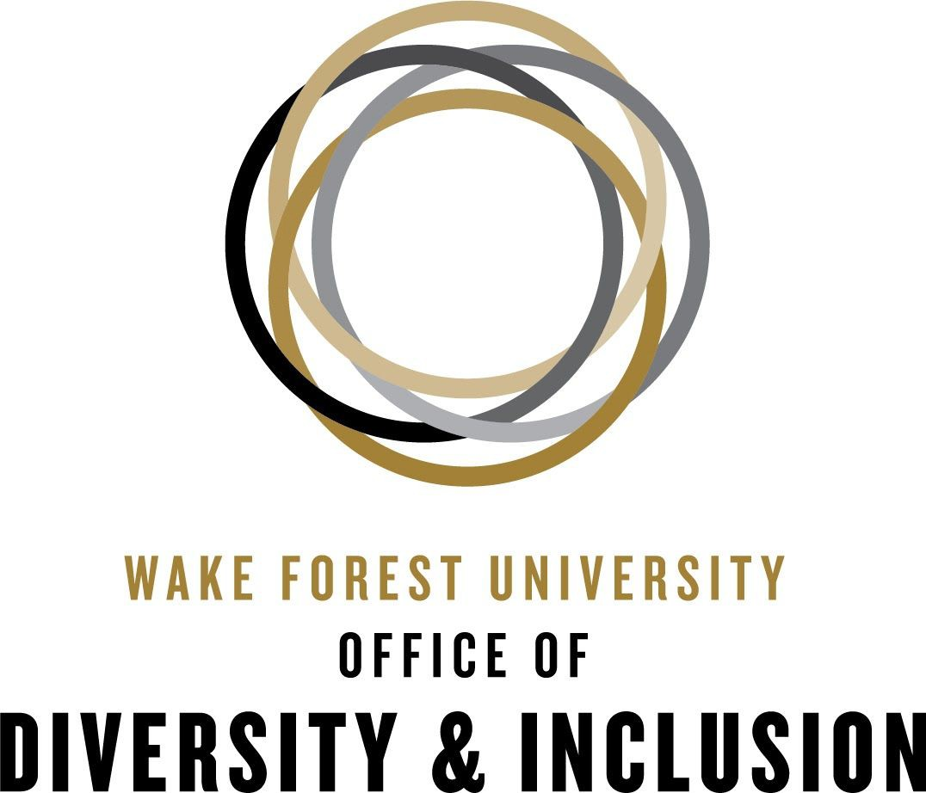
Building Inclusive Traditions and Practices

Traditions and organizational practices are at the heart of any group’s collective identity. At Wake Forest, traditions are one of the things that help make Mother So Dear a home to her students, faculty and staff. As we work to develop a campus culture that recognizes and celebrates the diversity in our community, it is important to keep in mind the ways we can recognize and address the organizational traditions and practices that may be unintentional barriers to our goal of inclusivity. Below are some questions to pose when planning, organizing, and/or participating in departmental or institutional traditions and practices:

- Is this tradition or practice based in contemporary or historical violence towards any group?

How can we modify or eliminate the aspects of this tradition or practice which are based in discriminatory practice towards:
- People with non-traditional gender identities
- People with different cultural/ethnic groups
- People from different age groups
- People from different religious groups
- People from racialized groups
- People who are differently abled
- People with non-heterosexual orientations

For example, Fraternity and Sorority date functions may make assumptions about gender and sexuality that exclude or marginalize LGBTQ folks.

It is important to realize that sometimes a practice or tradition is based in socio-historical violence and cannot take place without perpetuating harm against a group. This is why it is important to know the origins and impacts of a tradition or practice on different members of your campus or departmental community.
An organization, institution, or department can discover the contemporary or historical impacts of a tradition or practice by designating members of the group as tradition and practice vetters. Though it may be difficult to find all information on a practice or tradition, having researchers dedicated to such explorations reduces the likelihood of perpetuating discriminatory practices. When all else fails, ask your community members!

- Does this tradition or practice create barriers to participation? If so, how can we re-imagine it so there are no barriers for:
- Individuals with assistance animals
- Individuals with sensory deficits (low vision, low hearing)
- Individuals using different types of mobility devices
- Individuals with children
- Individuals with dietary restrictions and allergies
- Other individuals who are differently abled

Instead of making accommodations for differently abled individuals, create events and learning experiences that are accessible to everyone. This removes unnecessary barriers to community involvement. For more on Universal Design in Higher Ed. and in the context of a pandemic, take a look at these two resources:

III. Also consider these questions when planning or implementing events: - Whose experiences and identities are being centered by this tradition or practice?
- Does this tradition or practice center one group’s experiences by marginalizing another group's experiences?
- Are the distribution of power and expression surrounding this tradition replicating
the structure of our society? If so, how?
- Is this tradition or practice rooted in the cultural experience of a different group without their consultation or engagement?

An example of power dynamics impacting the community can be found in the tradition of rolling the quad. While this tradition is fun and tied to Wake Forest’s culture, it also results in hours of clean-up work for our facilities staff.
Power dynamics can also become visible in instances of cultural appropriation (The unacknowledged or inappropriate adoption of the customs, practices, ideas, etc. of one people or society by members of another and typically more dominant people or society). Having themed events based on different groups’ ethnic experiences represent a prototypical example of cultural appropriation, but more subtle examples such as adopting symbols, concepts, or ideas from other cultures in departmental, organizational, or institutional advertisements without understanding or referencing the group from which the ideas, symbols, or concepts are taken.

Wake Forest Tradition:
Lighting of the Quad

Is this tradition or practice based in contemporary or historical violence towards any group?
While centered in Catholicism, does not seemingly celebrate violence against any
non-hegemonic group*, but it has the potential to engender feelings of exclusion in those of different faith traditions.
*Hegemonic group- Any group that is dominant in a political or social context.

Does this tradition or practice create physical barriers to participation? If so, how can we disrupt that?

The location of lighting of the quad is seemingly accessible to everyone. But because of our awareness, we can check to be sure that no physical barriers exist and. work with others to overcome those that do.

Whose experiences and identities are being centered by this tradition or practice?
This event centers on Christian identity

Does this tradition or practice center one group's experiences by marginalizing another group's experiences? If so, how can we disrupt that?

While this event does not seemingly marginalize other identities intentionally, the scale of the event and the marginal scale of other faith traditions may highlight an institutional privileging of Christian identity over other faith traditions. Working to highlight other traditions during the same period of time might offset the hegemony of this tradition.

Are the distribution of power and expression surrounding this tradition replicating the structure in our society? If so, how, and how can we change it?
The focus on this tradition is indicative of Christian normativity in the larger United States and thus replicates the privilege afforded to Christians in the larger society. Though changing the national norm may not be within our power, we at Wake Forest University can draw attention to the norm and uplift experiences outside of it to create equity in holiday observance.

This is just one example of how to apply these guiding questions to a tradition or a practice. This guide can be used to evaluate any established traditions or practices:
- Greek Organization Practices/Traditions
- Departmental Practices/Traditions
- Communal Practices/Traditions (such as Project Pumpkin)
- Other University Traditions (such as rolling of the quad)

What to consider when practicing tradition
- Is this tradition or practice based in contemporary or historical violence towards any group?
- Does this tradition or practice create barriers to participation?
- Whose experiences and identities are being centered by this tradition or practice?

Ultimately, these questions exist to help us think about the impact of our traditions and practices on our community with hopes of developing greater inclusivity across all identity groups.

References:

Anastasia Glushko, & Debrosse, R. (2015). Equity and Diversity Checklist. McGill University. https://pgss.mcgill.ca/document/view/2521/Equity%20Checklist%20for%20Events.pdf
Beatty, C. C., & Boettcher, M. L. (2019). My culture is not a costume: Institutional practices and racism. New Directions for Student Services, 2019(165), 39–49. https://doi.org/10.1002/ss.20292
Kafer, A. (2013). Bodies of nature: The environmental politics of disability. In Feminist, queer, crip. Indiana University Press.

