Making the Invisible Visible: Microaggressions

Imagine these scenarios:
A search committee hiring a department chair in environmental science is meeting to discuss the final list of candidates, which includes two men and one woman. During the discussion, a male committee member says, “I think we should hire one of the men. I won’t work for a woman.”
Your computer information systems department is hiring a new assistant professor. Following a presentation from the candidate, who is a Black woman, a committee member provides feedback and says, “You’re so well spoken”. The candidate is visually uncomfortable, and the committee member is unsure why the candidate seems bothered..
During a meeting of the faculty search committee on which you are serving, almost every time a woman colleague tries to speak, she is interrupted by a male colleague. No one says anything when this happens. Finally, your woman colleague stops trying to offer contributions to the discussion. You wonder what she wanted to say.
Alex is a candidate for a tenure-track job in chemistry. During their on-campus interview, the chairperson of the search committee is giving a tour and refers to Alex as “he”. Alex, addresses the chair and says, my pronouns are they/them/their”. As they walk through the department labs, the chairperson makes a point of saying, “You look more like a he than a they”
These are examples of “microaggressions.” Defining Microaggressions Microaggressions:
- Are verbal and nonverbal behaviors
- Communicate negative, hostile, and derogatory messages to people rooted in their marginalized group membership (based on gender, race, ethnicity, sexuality, etc.)
- Occur in everyday interactions
- Can be intentional or unintentional
- Are often unacknowledged

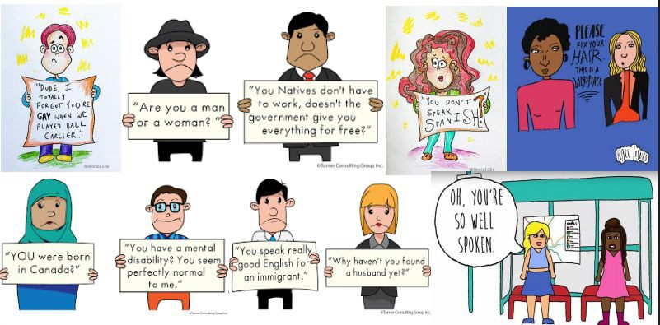
Figure 1: Artisitic representations of common microagressions

Three Forms of Microaggressions
Microassaults | Microinsults | Microinvalidations
- Name-calling, avoidant behavior, or purposeful discriminatory actions  - Likely to be conscious and deliberate | - Convey  stereotypes, rudeness, and insensitivity that demean a person’s identity  - Are frequently unknown to the person making the insult | - Exclude, negate, or dismiss the thoughts, feelings, or experiences of certain groups  - May be the most damaging form of the three microaggressions

The Challenges of Responding to Microaggressions
Dilemma #1: The Invisibility of Unintentional Expressions of Bias
  - Tend to be subtle, indirect, and unintentional
  - Occurs when other rationales for prejudicial behavior can be offered, such as blaming it on a stereotype (all people like this, do that…)
Dilemma #2: Perceived Minimal Harm of Microaggressions
  - When people say things like “Just let it go,” “You are overreacting,” or “It’s not a big deal”
  - The cumulative effect of microaggressions can be more problematic and detrimental than overt acts of prejudice
Dilemma #3: The Catch-22 of Responding to Microaggressions Challenges faced by the Victim:
  - Determining that a microaggression has actually occurred
  - Figuring out how to react when not responding may have detrimental effects
  - Responding with anger and striking back will likely engender negative consequences
How to address Microaggressions

ASK FOR CLARIFICATION OR MORE INFORMATION
  - “Could you say more about what you mean by that?”
  - “How have you come to think about that?”
  - “I think I heard you saying (paraphrase their comments). Is that correct?”
  - “I don’t get it…….”
  - “Why is that funny?

ACKNOWLEDGE THE FEELINGS OF THE PERSON EXPERIENCING THE MICROAGGRESSION
  - Express empathy and compassion.
  - “It sounds like you’re really frustrated/nervous/angry… ”
  - “I can understand that you’re upset when you feel disrespected.”

SEPARATE INTENT FROM IMPACT
  - “I know you didn’t realize this, but when you said
(comment/behavior), it was hurtful/offensive because Instead you could say (different language or behavior.)”

SHARE YOUR OWN PROCESS
  - “I noticed that you (comment/behavior). I used to do/say that too, but then I learned ”

EXPRESS YOUR FEELINGS
  - “When you (comment/behavior), I felt (feeling)
and I would like you to ”

CHALLENGE THE STEREOTYPE
  - Give information, share your own experience and/or offer alternative perspectives.
  - “Actually, in my experience ”
  - “I think that’s a stereotype. I’ve learned that ”
  - “Another way to look at it is ”

APPEAL TO VALUES AND PRINCIPLES
  - “I know you really care about Acting in this way really undermines
those intentions.”

PROMOTE EMPATHY
  - Ask how they would feel if someone said something like that about their group, or their friend/partner/child.
  - “I know you don’t like the stereotypes about (their group), how do you think he feels when he hears those things about his group?”

TELL THEM THEY’RE TOO SMART OR TOO GOOD TO SAY THINGS LIKE THAT
  - “Come on. You’re too smart to say something so ignorant/offensive.”

USE HUMOR
  - Exaggerate comment, use gentle sarcasm.
  - “She plays like a girl?” You mean she plays like Serena Williams?” “Or Mia Hamm?”

POINT OUT WHAT THEY HAVE IN COMMON WITH THE OTHER PERSON
  - “I’m tired of hearing your Muslim jokes. Do you know he’s also studying and likes to ____________________________?
  - You may want to talk with him about that. You actually have a lot in common.”

W.I.I.F.T. (What’s in it for them)
- Explain why diversity or that individual/group can be helpful/valuable.
- “I know you’re not comfortable with but they can help us reach out to/better serve other groups on campus/in the community.”
- “In the real world, we are going to have to work with all sorts of people, so might as well learn how to do it here.”

REMIND THEM OF THE RULES OR POLICIES
- “That behavior is against our code of conduct and could really get you in trouble.”

Moving Forward: How to Overcome Microaggressions
- Individual Intervention
  - Develop an honest awareness of our own biases, prejudices, and stereotypes
  - Become an ally and activist
- Departmental/Organizational Intervention
  - Make sure policies, practices, and procedures allow for equitable access and opportunity, and a way to report and hold those accountable who use a microaggression
  - Provide professional development opportunities
  - Make accountability central by putting policies and trainings in place that provide education and ways to address microaggressions when they occur
- Societal/Cultural Intervention
  - Critically assess cultural communication by including perspectives and photos of people from various backgrounds and using inclusive language when discussing experiences
  - Promote multi-cultural education, bias training, and use of the RIDE Framework as a means to uncover areas where additional training and resources are needed

Where should you go to report microaggressions at WFU?
The Report Bias website is a communication channel for members of our community to share their experiences with us. Even if you’re not sure if what you witnessed or experienced was bias-related, we still want to hear from you.

What happens next?
- University Police will assess the situation for danger of imminent harm.

- A team led by the Dean of Students and the Office of Diversity & Inclusion will review the report and reach out to you to provide care, offer support, and learn more about the incident. If needed, the Dean’s team will direct the report to the appropriate office for investigation.

References

A guide to responding to microaggressions – women in engineering. (n.d.). Retrieved July 31, 2020, from https://wie.engineering.illinois.edu/a-guide-to-responding-to-microaggressions/

Capodilupo, C. M., Nadal, K. L., Corman, L., Hamit, S., Lyons, O. B., & Weinberg. (2010). In D. W. Sue (Ed.), Microaggressions and Marginality: Manifestation, Dynamics, and Impact (pp. 193–216). John Wiley & Sons.

http://jonathanmoore.com | @newezra, S. H. co | @stylehatch / J. M.-. (n.d.). Power, privilege, and everyday life. -. Power, Privilege, and Everyday Life. Retrieved July 31, 2020, from https://www.microaggressions.com
Microaggressions in everyday life—Youtube. (n.d.). Retrieved July 31, 2020, from https://www.youtube.com/watch?v=BJL2P0JsAS4
Microaggressions in the classroom: Manifestation, dynamics and impact—Youtube. (n.d.). Retrieved July 31, 2020, from https://www.youtube.com/watch?v=sW3tFpThHzI
Nadal, K. L. (2010). Gender Microaggressions and Women: Implications for Mental Health. In Feminisms and Women’s Rights Worldwide (Vol. 2, pp. 151–175). Praeger.
Sue, D. W. (2010a). Microaggressions and marginality: Manifestation, dynamics, and impact. Wiley. Sue, D. W. (2010b). Microaggressions in everyday life race, gender, and sexual orientation. Wiley.
http://www.myilibrary.com?id=255005

What kind of Asian are you? - YouTube. (n.d.). Retrieved July 31, 2020, from https://www.youtube.com/watch?v=DWynJkN5HbQ

