The purpose of the tool guide is to provide information and guidance on how to create and maintain "Other Support" for NIH and NSF proposals. This tool guide will assist with becoming familiar with some of the Wake Forest University (WFU) organizational infrastructure when working on "Other Support."

The tool guide applies to individuals working on and assisting with preparing an "Other Support" document such as Grant and Contract Managers, ORSP staff, and Principal Investigators.

**As of July 31, 2020, NIH has provided additional guidance regarding Foreign Influence. Information found within Section 6 includes NIH requirements for Disclosure of Other Support, Foreign Relationships and Activities, as well as Conflicts of Interest.

TABLE OF CONTENTS
Page
Section 1: BACKGROUND / DEFINITIONS…………………………………………..…………………………….…...2
Section 2: REGULATIONS / GUIDELINES………………………………………………….……………………….….6
Section 3: INTERNAL & EXTERNAL SYSTEMS TO ACCESS………………………………….……………….……8
Section 4: WHERE INFORMATION IS OBTAINED FROM…………………………………………….…………...…9
Section 5: OBTAINING INFORMATION FROM EXTERNAL SYSTEMS………………………………….…….….11
Section 6: **FOREIGN INFLUENCE: REQUIREMENTS FOR DISCLOSURE……………………………..………..14
NIH Disclosure Grid…………………………………………………………………………………….15
RPPR Other Support Sample……………………………………………………………………………16
JIT Other Support Sample………………………………………………………………………………18
Section 7: OTHER SUPPORT vs. BIOSKETCH GRID………………………………………………………….......…21
Section 8: ADDITIONAL RESOURCES / WEBLINKS.……………………..…………………………...….…............25

** New Information

SECTION 1: BACKGROUND / DEFINITIONS

Below is a general listing of definitions/terms one will become familiar with when working on "Other Support." An extensive list of glossary terms is available on NIH web links listed below.
https://grants.nih.gov/grants/glossary.htm

B

- Budget Period: The intervals of time (usually 12 months each) into which a project period is divided for budgetary and funding purposes.
C

- Co-Investigator: An individual involved with the PD/PI in the scientific development or execution of a project. The Co-Investigator (collaborator) may be employed by, or be affiliated with, the applicant/recipient organization or another organization participating in the project under a consortium agreement. A Co-Investigator typically devotes a specified percentage of time to the project and is considered Key/Senior personnel. The designation of a Co-Investigator, if applicable, does not affect the PD/PI's roles and responsibilities as specified in the NIH Grants Policy Statement, nor is it a role implying multiple PD/PI. https://grants.nih.gov/grants/glossary.htm#CoInvestigator

- Co-Principal Investigator: The role type, "co-PI," is not used by the NIH, but is allowable with NSF.

- Collaborators: are typically listed as key personnel. They may get part of their salary paid from the Grant in person-months. Collaborators at other institutions could have their salary paid through a consortium agreement (also called a sub-award). Collaborators always play an active role in the research.
https://www.niaid.nih.gov/grants-contracts/consultants-collaborators-subawards

- Commercial Organization: An organization, institution, corporation, or other legal entity, including, but not limited to, partnerships, sole proprietorships, and limited liability companies, that is organized or operated for the profit or benefit of its shareholders or other owners. The term includes small and large businesses and is used interchangeably with "for-profit organization."
https://grants.nih.gov/grants/glossary.htm#CommercialOrganization

- Contact PD/PI: when multiple PD/PIs are designated, NIH requires that the applicant organization identify one of the PD/PIs as the Contact PD/PI to serve as a primary point of contact. Serving as Contact PD/PI confers no special authorities or responsibilities within the project team. The Contact PD/PI must meet all eligibility requirements for PD/PI status. However, as with the single PD/PI model, if the Contact PD/PI is not an employee, the applicant organization must have a formal written agreement with the Contact PD/PI that specifies an official relationship between the parties. (See NIH Grants Policy Statement: (Multiple Program Director/Principal Investigator Applications and Awards). https://grants.nih.gov/grants/glossary.htm#ContactPDPI
D

- Direct Costs: costs that can be identified specifically with a particular sponsored project, an instructional activity, any other institutional activity, or that can be directly assigned to such activities relatively easily with a high degree of accuracy.
E

- Effort: Effort is the measurement of personnel time devoted to a specific task. Time provided to sponsored projects is required to be monitored and documented to guarantee the amount of pledged time is equal to the time spent. The percentage of salary paid by a sponsored project must not exceed the amount of time spent on the project.

- eRA Commons (electronic Research Administration): an online interface where grant applicants, grantees and federal staff at NIH and grantor agencies can access and share administrative information relating to research grants. https://era.nih.gov/commons/index.cfm
G

- Grant Number: the number assigned by the agency to identify the type of application (1), activity code (R01), an organization to which it is assigned (AI); serial number assigned by the Center for Scientific Review (183723), suffix showing the support year for the Grant (01) and other information identifying a revision (S1), resubmission (A1) or a fellowship's institutional allowance. Example: 1-R01-AI183723-01
https://grants.nih.gov/grants/glossary.htm#GrantNumber
J

- Just-in-Time (JIT): NIH policy allows the submission of certain elements of a competing application to be deferred until later in the application process, after review when the application is under consideration for funding. Within the Status module of the eRA Commons, users will find a feature to submit Just-In-Time information when requested by the NIH. Through this module, institutions can electronically submit the information that is requested after the review but before award. See Completing the Pre-Award Process-Just-In-Time Procedures for additional information. https://grants.nih.gov/grants/glossary.htm#JustInTimeJIT
K

- Key/Senior Personnel: the PD/PI and other individuals who contribute to the scientific development or execution of a project in a substantive, measurable way, whether or not they receive salaries or compensation under the Grant. Typically, these individuals have doctoral or other professional degrees, although individuals at the masters/baccalaureate level may be considered Key/Senior personnel if their involvement meets this definition. Consultants and those with a postdoctoral role also may be considered Key/Senior Personnel if they meet this definition. Key/Senior Personnel must devote measurable effort to the project whether or not salaries or compensation are requested. "Zero percent" effort or "as needed" are not acceptable levels of involvement for those designated as Key/Senior Personnel. https://grants.nih.gov/grants/glossary.htm#SeniorKeyPersonnel
N

- NCE (No Cost Extension): an extension of time to a project period and/or budget period provided by the Sponsor to complete the work without additional funding or competition.

- NIH (National Institutes of Health): the principal federal agency for health research in the United States. The NIH is part of the Department of Health and Human Services.

- NGA (Notice of Award): the legal document issued to notify the recipient that an award has been made and that funds may be requested from the designated HHS payment system/office. The NGA is issued for the initial budget period and each subsequent budget period in the approved project period, which can reflect any future-year commitments. https://grants.nih.gov/grants/policy/nihgps/html5/section_5/5_the_notice_of_award.htm

- NSF (National Science Foundation): an independent federal agency created by Congress in 1950 "to promote the progress of science; to advance the national health, prosperity, and welfare; to secure the national defense..." NSF supports basic research to create knowledge that transforms the future.

O

- Other Significant Contributors (OSCs): Individuals who have committed to contribute to the scientific development or execution of the project but are not committing any specified measurable effort (i.e., person-months) to the project. These individuals are typically presented at "effort of zero person months" or "as needed." Individuals with measurable effort may not be listed as Other Significant Contributors (OSCs). Consultants should be included if they meet this definition.
https://grants.nih.gov/grants/glossary.htm#OtherSignificantContributorsOSCs

- Other Support/Active and Pending Support: The disclosure of all financial sources—whether Federal, non-Federal, commercial—available in direct Support of an individual's research endeavors, including but not limited to research grants, cooperative agreements, contracts, and institutional awards. Funding for training awards, prizes, and gifts are not required to be included.

- Overlap of Support: Other Support duplicating research or budgetary items already funded by an NIH grant. Overlap also occurs when any project-supported personnel has time commitments exceeding 12 person-months.
https://grants.nih.gov/grants/glossary.htm#OverlapofSupport
P

- Person Months: The metric for expressing the effort (amount of time) PD/PI(s), faculty, and other senior/key personnel devote to a specific project. The effort is based on the type of appointment of the individual with the organization, e.g., calendar year, academic year, and/or summer term, and the organization's definition of such. For instance, some institutions define the academic year as a 9-month appointment while others define it as a 10-month appointment. See also Frequently Asked Questions Regarding the Usage of Person Months.
https://grants.nih.gov/grants/glossary.htm#PersonMonths

- Program Director/Principal Investigator (PD/PI): The individual(s) designated by the applicant organization to have the appropriate level of authority and responsibility to direct the project or program to be supported by the award. The applicant organization may designate multiple individuals as program directors/principal investigators (PD/PIs) who share the authority and responsibility for leading and directing the project, intellectually and logistically. When multiple PD/PIs are named, each is responsible and accountable to the applicant organization, or as appropriate, to a collaborating organization for the proper conduct of the project or program including the submission of all required reports. The presence of more than one PD/PI on an application or award diminishes neither the responsibility nor the accountability of any individual PD/PI.
https://grants.nih.gov/grants/glossary.htm#ProgramDirectorPrincipalInvestigatorPDPI

- Project Goal(s): short statement of the main goal(s) of the project. It must be a maximum of two sentences.

- Project Begin/End Dates: The time during which the recipient may incur new obligations to carry out the work authorized under the award.
R

- RPPR (Research Performance Progress Report): Progress reports are required annually to document grantee accomplishments and compliance with terms of the award. They describe scientific progress, identify significant changes, report on personnel, and describe plans for the subsequent budget period or year. https://grants.nih.gov/grants/glossary.htm#ResearchPerformanceProgressReportRPPR
S

- Scientific Overlap: Overlap of Support occurs when substantially similar research is proposed in more than one concurrent PHS grant application. https://grants.nih.gov/grants/glossary.htm#ScientificOverlap

- Senior Personnel: the individual(s) designated by the grantee and approved by NSF who will be responsible for the scientific or technical direction of the project. If more than one, the first one listed will have primary responsibility for the project and the submission of reports. https://www.nsf.gov/pubs/gpg/nsf04_23/appf.jsp

BACK TO TABLE OF CONTENTS

SECTION 2: REGULATIONS / GUIDELINES

When working on "Other Support," there are several regulations to abide by and guidelines to follow. Below is a listing of these regulations/guidelines when working on "Other Support" for NIH, NIH RPPR, Just-in-Time, and NSF.

- NIH Guidelines:
https://grants.nih.gov/grants/forms/othersupport.htm

Information on other active and pending Support may be requested (often as part of Just-in-Time procedures for grant applications or in progress reports - RPPR) to ensure there is no scientific, budgetary, or commitment overlap. "Other Support" is sometimes referred to as "current and pending support" or "active and pending support." Other Support includes all financial resources, whether Federal, non-Federal, commercial or institutional, available in direct Support of an individual's research endeavors, including but not limited to research grants, cooperative agreements, contracts, and/or institutional awards. Training awards, prizes, or gifts do not need to be included.

Other Support information is requested for: (1) All individuals designated in an application as senior/key personnel, except Program Directors, training faculty, and other individuals involved in the oversight of training grants. Individuals categorized as Other Significant Contributors. (2) All senior/key personnel, excluding consultants, in progress reports when there has been a change in active other Support, except Program Directors, training faculty, and other individuals involved in the oversight of training grants.

NIH has long required full transparency for all research activities both domestic and foreign. For more information about the policies regarding Financial Conflicts of Interest and Foreign Components, please refer to the NOT-OD-19-114 released July 10, 2019 from NIH.

To assist with the percentage of effort to calendar months conversion, NIH has provided NIH Person Months
Conversion Chart.

Information Collected Includes
- Project Number | - Title of Project / Sub-project
- Contact Principal Investigator | - Dates of approved/proposed Project
- Source of Support / Sponsor | - Effort listed in calendar months

Additional Resources:
- NIH Other Support Template
- NIH Grant Policy Statement, Section 2.5.1
- NIH FAQ – Other Support & Foreign Components

- RPPR Guidelines:
Submit Other Support for all new senior/key personnel and updated Other Support for all senior/key personnel for whom there has been a change since the last reporting period. Provide only active Support for all new senior/key personnel. Provide updated other supported for all senior/key personnel for whom there has been a change in Other Support. If a previously active grant has terminated and/or if a previously pending grant is now active, update by annotating accordingly, effort devoted to projects must be reported in person-months; indicate calendar, academic, and/or summer months associated with each project.

Additional Resources:
- NIH RPPR Non-Competing Other Support Sample
- NIH RPPR Non-Competing Other Support Format Instructions

- JIT Regulations/Guidelines:
https://grants.nih.gov/grants/policy/nihgps/HTML5/section_2/2.5.1_just-in-time_procedures.htm

Other Support Information on other active and pending Support will be requested as part of the Just-In-Time procedures. Other Support is requested for all individuals designated in an application as Key/Senior Personnel - those devoting measurable effort to a project. "Zero percent" effort or "as needed" are not acceptable levels of involvement for those designated as Senior/Key Personnel.

NIH program and grants management staff will review this information before award to ensure the following:
- Sufficient levels of effort are committed to the project.
- Only funds necessary to the approved project are included in the award.
- There is no scientific, budgetary, or commitment overlap.
- Scientific overlap occurs when (1) substantially the same research is proposed in more than one application or is submitted to two or more funding sources for review and funding consideration or (2) a specific research objective and the research design for accomplishing the objective are the same or closely related in two or more applications or awards, regardless of the funding source.
- Budgetary overlap occurs when duplicate or equivalent budgetary items (e.g., equipment, salaries) are requested in an application but already are provided by another source.
- Commitment overlap occurs when an individual's time commitment exceeds 100 percent (i.e., 12 person-months), whether or not salary support is requested in the application.
- Overlap, whether scientific, budgetary, or commitment of an individual's effort greater than 100 percent, is not permitted. Any overlap will be resolved by the IC with the applicant and the PD/PI at the time of the award.

Additional Resources:
- NIH JIT Competing Other Support Sample
- NIH JIT Competing Other Support Format Instructions

- NSF Guidelines:
Current and pending support information must be separately provided through use of an NSF-approved format, for individuals designated as senior personnel on the proposal. Current and pending support includes all resources made available to an individual in support of and/or related to all of his/her research efforts, regardless of whether or not they have monetary value. Current and pending support also includes in-kind contributions (such as office/laboratory space, equipment, supplies, employees, students. In-kind contributions not intended for use on the project/proposal being proposed also must be reported.

Current and pending support information must be provided for the proposal project, for ongoing projects, and for any proposals currently under consideration from whatever source, irrespective of whether such support is provided through the proposing organization or is provided directly to the individual.

The total award amount for the entire award period covered (including indirect costs) must be provided, as well as the number of person-months (or partial person-months) per year to be devoted to the project by the individual.

Additional Resource:
NSF-Approved Formats for Current and Pending Support
https://www.nsf.gov/bfa/dias/policy/cps.jsp
BACK TO TABLE OF CONTENTS

SECTION 3: INTERNAL & EXTERNAL SYSTEMS TO ACCESS

      - Cayuse
Internal WFU system to obtain records, retrieve active grant projects, personnel, sponsors, dates, and original proposal information. Further details on how to acquire access can be found on the ORSP’s website: https://wfu.cayuse424.com/

2. Workday
Internal WFU system used for everyday human resources and financial management processes. Can be used to obtain records, retrieve active grant projects expenditures and available balance, performance dates, and effort information. Further details on how to acquire access can be found on WFU’s website: https://www.myworkday.com/wfu

      - External Systems to Access

NIH (National Institute of Health) RePorter
NIH system used to obtain Proposal information. This system can be used to look up grant-information when WFU is a subcontract, status on RPPR, or JIT submissions. To learn how to use NIH RePorter, NIH has provided video NIH RePort Tutorials.
Areas of Access Needed:
- Admin Header
- Status Header
- RPPR Header

eRA Commons
NIH system is used to obtain Proposal information. To learn how to use NIH eRA Commons, NIH has provided video eRA Help & Tutorials.
Areas of Access Needed:
- Admin Header
- Status Header

NSF (National Science Foundation)
Research.gov https://www.research.gov/research-web/
Research.gov provides grants management for the research community. Research.gov will become the replacement for FastLane, providing quick access to research information and grants management services, all in one location.

BACK TO TABLE OF CONTENTS

SECTION 4: WHERE INFORMATION IS OBTAINED

The below grid provides guidance as to where information can be obtained from and the appropriate placement on the Other Support document.

ITEM | OBTAINED FROM | DETAILS
ACTIVE | Cayuse SP, Workday | Research Projects awarded and not expired
PENDING | Cayuse SP | Grants in the process of being approved but haven't been awarded.
Grant Number | Cayuse SP, Workday | An award number assigned by the Sponsor or Agency
Primary Award PI | Cayuse SP, NIH RePorter  Workday | If WFU is a sub, then search NIH RePorter
Project Start/End Dates | Cayuse SP, Workday | Dates may have changed, double-check the NGA
(NCE) | --- | Look at NGA
Effort | Workday | NIH requires effort to be shown in Calendar, Academic, or Summer months only. A reduction of effort of more than 25% requires approval from the sponsor
Sponsor Agency | Cayuse SP, Workday | Primary federal agency or other sponsor providing funding
Annual Direct Costs | Cayuse SP | Look at NGA
Project Title | Cayuse SP, Workday | If the title is incomplete
Major Goals | Cayuse 424, eRA Commons, Research.gov | The overall goals of the project found in the Narrative section of the proposal (NIH) or Project Description (NSF)
Overlap | Key Personnel | Identifies any scientific, budgetary, and commitment overlap that would occur if the current proposal were approved. If the total (Active & Pending) Effort exceeds 12, a statement must be included. It is an opportunity for the PI to explain any Overlap that appears/might exist between any two or more grants.
Additional Resources:
- NIH RPPR Non-Competing Other Support Sample
- NIH RPPR Non-Competing Other Support Format Instructions
- NIH JIT Competing Other Support Sample
- NIH JIT Competing Other Support Format Instructions
NSF Current and Pending Support Sample Template
NSF-Approved Formats for Current and Pending Support
FAQs on Current and Pending Support

BACK TO TABLE OF CONTENTS

SECTION 5: OBTAINING INFORMATION FROM EXTERNAL SYSTEMS

ORSP is happy to obtain this information for you, if needed. If you prefer to research yourself, please use the following steps for NIH awards.

Step 1: A copy of the NoGA can be obtained from eRA Commons. Once you are logged into eRA Commons, click on the "Status" option from the menu options.

- The General Search box will populate with this selection. Enter the PI's name in the required field (red). Delete the information that is pre-populated in the "Budget Start Date" section to ensure that all possible dates populate (blue). Click on "Search."

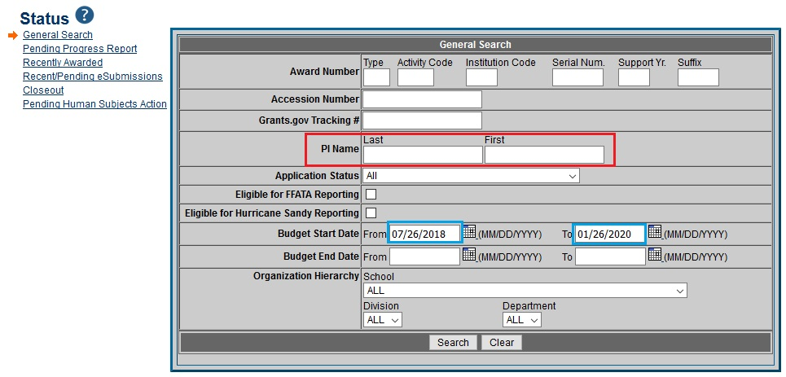

- Select the correct grant number of the list available.

- Once selected, all of the information for that Grant will be provided. In the "Other Relevant Documents" section, click on the date for the NoGA.
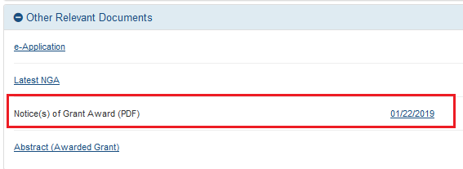
Step 2: From the NoGA, you will be able to obtain
- Grant Number
- Project Title
- Project Period Dates, under "Period of Performance."
- Total Federal Award Amount, under "Award Data."

Step 3: To obtain the goal: refer back to the "Other Relevant Documents" from eRA Commons and click on the "e-Application" link.

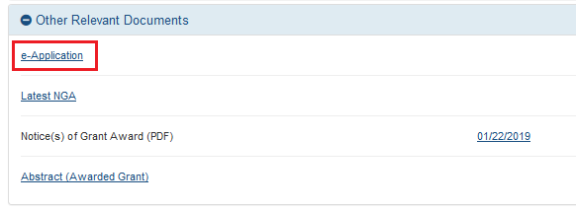

- On the PDF application attachment, click on the "Project Narrative" header that will show on the left side of the document in the Bookmark menu.
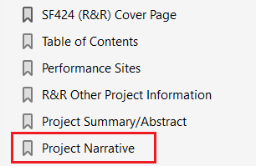

- From this document, highlight and copy the goal for your OS document

Step 4: Once all of the necessary information has been entered on your OS, you are finished with entering this active Grant. Follow these steps as necessary to input all Active grants. Below Active grants, enter the Pending grants given to you by the Key/Senior Personnel using the same formatting as Active grants. After inputting Active and Pending grants, calculate the total Calendar Months to check for any Commitment Overlap. If the Total Calendar Months DOES NOT exceed 12 months, then indicate "NONE" under the Overlap heading. If the Total Calendar Months DOES exceed 12 months, write a specific statement regarding any adjustments in the effort that will be made to accommodate for the Pending grants.

Step 5: Enter the link (https://projectreporter.nih.gov/reporter.cfm?frs=1&icde=43715497) to search for the Primary Award PI in the NIH RePorter if WFUHS is a subcontractor.
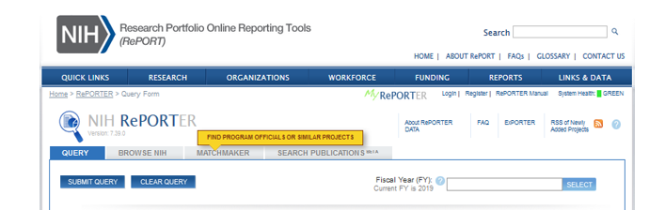

Step 6: Enter the Grant Number in the boxes indicated. Click Submit Query.
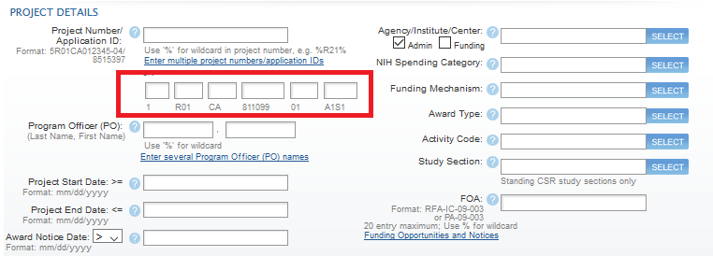

Step 7: The results of your inquiry will show. Click on the Project Number to view the details.
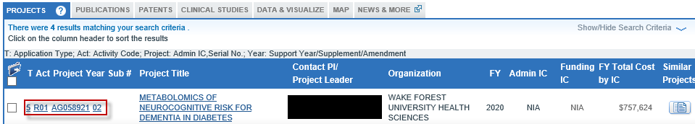

Step 8: The details regarding this Grant will populate. The Primary Award PI will be shown as below.
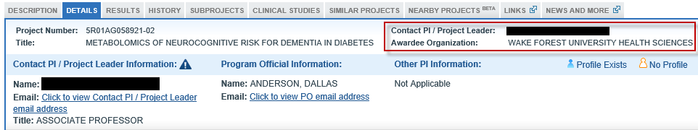

Step 9: To obtain the Goal via NIH RePorter's
- Within the "Description" menu option
- Review of Abstract Text

BACK TO TABLE OF CONTENTS

SECTION 6: FOREIGN INFLUENCE: REQUIREMENTS FOR DISCLOSURE

As of July 31, 2020, NIH has provided additional guidance regarding Foreign Influence. Due to the growing concerns regarding inappropriate Foreign Influence by foreign governments over federally funded research, full transparency in NIH applications and during the life cycle of the NIH grant is essential.

Inappropriate Foreign Influence:

In August 2018, the NIH Director issued a statement about incidents that violate core principles and threaten the integrity and academic competitiveness of U.S. biomedical research and innovation, including:

- Failure to disclose all conflicts of interest, foreign affiliations, conflicts of commitment, and other support in applications for NIH grants;

- Diversion of proprietary or pre-publication information disclosed in grant applications or produced by NIH-supported research to those not authorized to receive it; and

- Breaches of confidentiality in peer review.

NIH has taken a number of stages to address these risks, including convening a working group of the Advisory Committee to the Director (ACD) to deliberate on the matter and advise on how best to address it. The ACD delivered a set of recommendations, many of which are being implemented by NIH.

Requirements for Disclosure of Other Support, Foreign Relationships and Activities, as well as Conflicts of Interest:
Full transparency - NIH requires the disclosure of all sources of research support, prior approval of all foreign components, and appropriate reporting and management of financial conflicts of interest. NIH uses this information when making its funding decisions to determine if the proposed research is receiving financial or non-monetary support that could be duplicative, that sufficient time is available for the project, or if financial interests may affect objectivity in the conduct of the research.
√
Additional Resources:
- Protecting U.S. Biomedical Intellectual Innovation
- White House’s Office and Science and Technology Policy in June 2020
- Statement on Protecting the Integrity of U.S. Biomedical Research
- ACD Working Group on Foreign Influences on Research Integrity
- NOT-OD-19-114
- FAQ Other Support and Foreign Components

BACK TO TABLE OF CONTENTS
Examples of What to Disclose to NIH about Senior/Key Personnel on Applications and Awards:
Table 1: Recipients Must Report** (This table will be subject to change as form updates are made.)
Type of Activity | Report in Biosketch / Application | Report as Foreign Component in Application | Obtain Prior Approval and Report as Foreign Component in RPPR | Report as Other Support (JIT) | Report as Other Support (RPPR) | Review for potential FCOI
All positions and affiliations, including volunteer positions, relevant to the application | √ |  |  |  |  | √  If personal payments to the individual
Relevant appointments at foreign institutions – even if labeled as “guest,” “adjunct,” “honorary,” with or without salary support | √ |  |  |  |  | √  If personal payments to the individual
The number of person-months devoted to projects, even if there is no salary support or direct personal payments to the scientist |  |  |  | √ | √  If new
Income, salary, consulting fees, and honoraria in support of an individual's research endeavors |  |  |  | √ | √  If new | √
Participation in a foreign talent or similar-type programs |  |  |  | √ | √  If new | √
Ongoing and completed research projects from the past three years that the applicant wishes to highlight | √
All resources and other support, both domestic and foreign, for ongoing research projects, including those conducted at a different institution |  |  |  | √ | √  If new | √
In-kind contributions from domestic and foreign institutions or governments that support research activities |  |  |  | √ | √  If new | √
Performance of any significant part of an NIH project outside of the US, whether or not funds are expended |  | √ | √  If new
Post-doc, student, or visiting scholar supported by a foreign government or institution |  |  |  | √ | √  If new
Travel paid by a foreign institution or government over $5,000 per year |  |  |  |  |  | √
Financial interests received from a foreign Institution of higher education or a foreign government |  |  |  |  |  | √

BACK TO TABLE OF CONTENTS
RPPR OTHER SUPPORT SAMPLE
DESIGNED TO MEET NEW GUIDANCE RELEASED ON JULY 31, 2020
Disclosure on RPPR Other Support is within the pending section
https://grants.nih.gov/policy/protecting-innovation.htm

DOE, JANE

ACTIVE

1-R01-CA123456-01 (Starke) 07/01/19 - 06/30/25 1.80 CM
NIH $650,000
Integration of Biotechnology and Society
The goal of this project is to determine the best possible intervention for biotechnology in society.

1-R01-CA456789-01 (Skellington) 08/01/18 - 01/30/23 (NCE) 4.60 CM
NIH $0
Cancer Center Core Support Grant (Admin Core)
The goal of this project is to provide administrative support for the current Grant.

PENDING

1-R01-CA25849-01 (Jones) 05/01/21 - 08/30/25 2.24 CM
NCI $720,000
Breast Cancer Studies in Women over 50
The goal of this project is to discern the various types of breast cancer found in women of various races over 50.

OVERLAP (Reminder to address – commitment, scientific, and budgetary overlap)
There is a commitment overlap for Dr. Jones between 1-R01CA456789-01 and 1-R01-CA25849-01. If this application is funded, Dr. Jones will request approval to reduce his effort on 1-R01-CA25849-01 to 2 calendar months. There is no scientific or budgetary overlap.
DOMESTIC:

Income, salary, consulting fees, and honoraria in support of an individual's research endeavors:
  - Institution Name / Type / Amount
  - University of North Carolina at Greensboro / Honoraria / $1,000

Listing of all domestic resources and other support, for ongoing research projects, including those conducted at a different institution:
  - Institution Name / Type of domestic resource or other support:
  - Virginia Tech / Dr. Blue Lab / working on NIH grant 1-R01-CA25849-01 / running DNA sequencing

In-kind contributions from foreign institutions or governments that support research activities:
- Institution Name / Name of Lab / Describe in-kind contributions / Covering Period
  - Duke University / Dr. Strange Lab / worked on NIH grant 5R01AIXXXXXX-03 while serving as adjunct professor in summer 2020

Post-doc, student, or visiting scholar supported by a foreign government or institution:
- Institution Name / Individual Name / Type / Calendar Month FTE
- Boston University / Bruce Banner, PhD / Post-Doc / 6.00CM

FOREIGN:

Income, salary, consulting fees, and honoraria in support of an individual's research endeavors:
  - Institution or Government Name / Type / Amount
  - Government of China / Honoraria / $1,000

Participation in a foreign talent or similar-type programs:
  - Institution or Government Name / Title / Name of Program / Dollar Amount
  - Proteona Pte Ltd, Singapore / Proteona Oncology Challenge Grant Award / USD $50,000

Listing of all foreign resources and other support, for ongoing research projects, including those conducted at a different institution:
  - Institution or Government Name / Type of foreign resource or other support
  - Macquarie University, Australia / Board member / Consultation / No fee’s

In-kind contributions from foreign institutions or governments that support research activities:
- Institution or Government Name / Name of Lab / Describe in-kind contributions / Covering Period
- German Institute of Research / Gunther Stein Lab / work on university research grant while serving as adjunct professor cover period from July 1, 2019 to June 30, 2020

Post-doc, student, or visiting scholar supported by a foreign government or institution:
- Institution or Government Name / Individual Name / Type / Calendar Month FTE
- Pepper Potts, PhD / Visiting Scholar / University of Iceland / 6.00CM

BACK TO TABLE OF CONTENTS
JIT OTHER SUPPORT SAMPLE
DESIGNED TO MEET NEW GUIDANCE RELEASED ON JULY 31, 2020
Disclosure on JIT Other Support is per proposal within both active and pending sections
https://grants.nih.gov/policy/protecting-innovation.htm

DOE, JANE

ACTIVE

1-R01-CA123456-01 (Starke) 07/01/19 - 06/30/25 1.80 CM
NIH $650,000
Integration of Biotechnology and Society
The goal of this project is to determine the best possible intervention for biotechnology in society.

DOMESTIC:

Income, salary, consulting fees, and honoraria in support of an individual's research endeavors:
  - Institution Name / Type / Amount
  - If no response, enter: “No information to report.”

Listing of all domestic resources and other support, for ongoing research projects, including those conducted at a different institution:
  - Institution Name / Type of domestic resource or other support:
  - If no response, enter: “No information to report.”

In-kind contributions from domestic institutions or governments that support research activities:
- Institution Name / Name of Lab / Describe in-kind contributions / Covering Period
- If no response, enter: “No information to report.”

Post-doc, student, or visiting scholar supported by a domestic government or institution:
- Institution Name / Individual Name / Type / Calendar Month FTE
- If no response, enter: “No information to report.”

FOREIGN:

Income, salary, consulting fees, and honoraria in support of an individual's research endeavors:
  - Institution or Government Name / Type / Amount
  - If no response, enter: “No information to report.”

Participation in a foreign talent or similar-type programs:
  - Institution or Government Name / Title / Name of Program / Dollar Amount
  - If no response, enter: “No information to report.”

Listing of all foreign resources and other support, for ongoing research projects, including those conducted at a different institution:
  - Institution or Government Name / Type of foreign resource or other support
  - If no response, enter: “No information to report.”

In-kind contributions from foreign institutions or governments that support research activities:
- Institution or Government Name / Name of Lab / Describe in-kind contributions / Covering Period
- If no response, enter: “No information to report.”

Post-doc, student, or visiting scholar supported by a foreign government or institution:
- Institution or Government Name / Individual Name / Type / Calendar Month FTE
- If no response, enter: “No information to report.”

PENDING

1-R01-CA25849-01 (Jones) 05/01/21 - 08/30/25 2.24 CM
NCI $720,000
Breast Cancer Studies in Women over 50
The goal of this project is to discern the various types of breast cancer found in women of various races over 50.

OVERLAP (Reminder to address – commitment, scientific, and budgetary overlap)
There is a commitment overlap for Dr. Jones between 1-R01CA456789-01 and 1-R01-CA25849-01. If this application is funded, Dr. Jones will request approval to reduce his effort on 1-R01-CA25849-01 to 2 calendar months. There is no scientific or budgetary overlap.

DOMESTIC:

Income, salary, consulting fees, and honoraria in support of an individual's research endeavors:
  - Institution Name / Type / Amount
  - University of North Carolina at Greensboro / Honoraria / $1,000

Listing of all domestic resources and other support, for ongoing research projects, including those conducted at a different institution:
  - Institution Name / Type of domestic resource or other support:
  - Virginia Tech / Dr. Blue Lab / working on NIH grant 1-R01-CA25849-01 / running DNA sequencing

In-kind contributions from domestic institutions or governments that support research activities:
- Institution Name / Name of Lab / Describe in-kind contributions / Covering Period
  - Duke University / Dr. Strange Lab / worked on NIH grant 5R01AIXXXXXX-03 while serving as adjunct professor in summer 2020

Post-doc, student, or visiting scholar supported by a domestic government or institution:
- Institution Name / Individual Name / Type / Calendar Month FTE
- Boston University / Bruce Banner, PhD / Post-Doc / 6.00CM

FOREIGN:

Income, salary, consulting fees, and honoraria in support of an individual's research endeavors:
  - Institution or Government Name / Type / Amount
  - Government of China / Honoraria / $1,000

Participation in a foreign talent or similar-type programs:
  - Institution or Government Name / Title / Name of Program / Dollar Amount
  - Proteona Pte Ltd, Singapore / Proteona Oncology Challenge Grant Award / USD $50,000

Listing of all foreign resources and other support, for ongoing research projects, including those conducted at a different institution:
  - Institution or Government Name / Type of foreign resource or other support
  - Macquarie University, Australia / Board member / Consultation / No fee’s

In-kind contributions from foreign institutions or governments that support research activities:
- Institution or Government Name / Name of Lab / Describe in-kind contributions / Covering Period
- German Institute of Research / Gunther Stein Lab / work on university research grant while serving as adjunct professor cover period from July 1, 2019 to June 30, 2020

Post-doc, student, or visiting scholar supported by a foreign government or institution:
- Institution or Government Name / Individual Name / Type / Calendar Month FTE
- University of Iceland / Pepper Potts, PhD / Visiting Scholar / 6.00CM

BACK TO TABLE OF CONTENTS

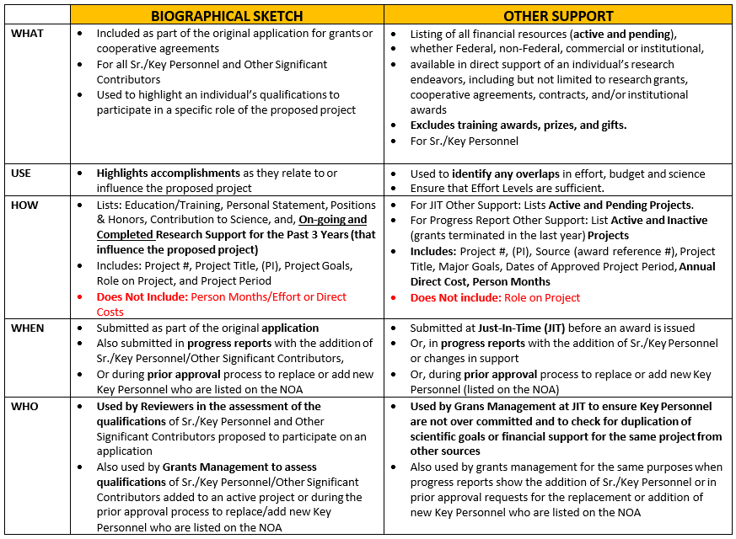

BACK TO TABLE OF CONTENTS

SECTION 7: FOREIGN INFLUENCE: REQUIREMENTS FOR DISCLOSURE

As of July 31, 2020, NIH has provided additional guidance regarding Foreign Influence. Due to the growing concerns regarding inappropriate Foreign Influence by foreign governments over federally funded research, full transparency in NIH applications and during the life cycle of the NIH grant is essential.

Inappropriate Foreign Influence:

In August 2018, the NIH Director issued a statement about incidents that violate core principles and threaten the integrity and academic competitiveness of U.S. biomedical research and innovation, including:

- Failure to disclose all conflicts of interest, foreign affiliations, conflicts of commitment, and other support in applications for NIH grants;

- Diversion of proprietary or pre-publication information disclosed in grant applications or produced by NIH-supported research to those not authorized to receive it; and

- Breaches of confidentiality in peer review.

NIH has taken a number of stages to address these risks, including convening a working group of the Advisory Committee to the Director (ACD) to deliberate on the matter and advise on how best to address it. The ACD delivered a set of recommendations, many of which are being implemented by NIH.

Requirements for Disclosure of Other Support, Foreign Relationships and Activities, as well as Conflicts of Interest:
Full transparency - NIH requires the disclosure of all sources of research support, prior approval of all foreign components, and appropriate reporting and management of financial conflicts of interest. NIH uses this information when making its funding decisions to determine if the proposed research is receiving financial or non-monetary support that could be duplicative, that sufficient time is available for the project, or if financial interests may affect objectivity in the conduct of the research.
√
Additional Resources:
- Protecting U.S. Biomedical Intellectual Innovation
- White House’s Office and Science and Technology Policy in June 2020
- Statement on Protecting the Integrity of U.S. Biomedical Research
- ACD Working Group on Foreign Influences on Research Integrity
- NOT-OD-19-114
- FAQ Other Support and Foreign Components

BACK TO TABLE OF CONTENTS

