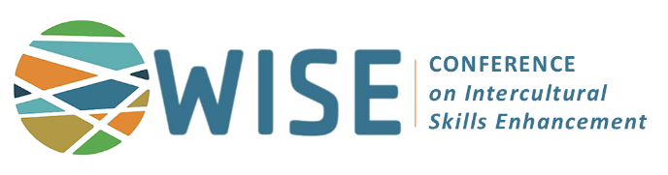
2027 Call for Workshop Proposals

The WISE Conference Steering Committee announces an open call for proposals to facilitate 2026 Workshops, four-hour intensive learning opportunities for participants to delve deeper into a specific topic related to intercultural learning. Workshop topics may range from intercultural skill building techniques, research methods, innovative pedagogies, intercultural training topics, resources for faculty designing/enhancing study abroad programs, and/or emerging topics related to campus-based global programs.
About WISE Conference
Hosted by the Center for Global Programs & Studies at Wake Forest University, the Workshop on Intercultural Skills Enhancement (WISE) is a pioneering conference for faculty leaders, program coordinators, administrators, and advisors to advance knowledge and skills for developing their students’ intercultural awareness during global experiences. The conference focus is “Enhancing Intercultural Learning at Home and Abroad.” WISE attracts a national audience of international educators, practitioners, and faculty across disciplines. The 19th annual WISE Conference will be held February 18-20, 2027, in Winston-Salem, NC.
Workshop Criteria
● Present current topics relevant to intercultural learning/training through four (4) hours of content
● Encourage discussion among participants and facilitate an interactive learning environment
● Provide concrete “take aways” for faculty and professional staff to utilize in their work
● Be supported by research in the field and/or professional experience
Tentative Workshop Schedule
Pre-Conference: Thursday, February 18, 2027 | 9:30am – 2:30pm, with lunch from 12:00 - 1:00pm
Invited workshop facilitators will receive registration for their workshop date as well as complimentary registration for the general WISE Conference.
Deadline: August 9, 2026 .
Contact wiseconference@wfu.edu with questions.
*The Call for Session Proposals is a separate process.
Pre-Conference Workshop Submission Form
WISE Conference - February 2027
Submit your complete proposal to wiseconference@wfu.edu
Deadline: August 9, 2026 .
1. Contact Details for Lead Facilitator
Name:
Title:
Institution/Organization:
Address:
Email:
Phone number (office):
Phone number (mobile):

If applicable --
Co-facilitator #1: name, title, organization, email

Co-facilitator #2: name, title, organization, email

2. Title of proposed workshop:

3. Describe the topic and content of your pre-conference workshop proposal, including learning goals and deliverables for participants.
4. Describe the target audience for your topic.
5. Describe the structure of your workshop and how you intend to make the workshop interactive for participants.
6. Provide a rough outline of how you will utilize the four hours allotted for workshops.
Thursday, February 18, 2027 | 9:30am – 2:30pm, with lunch from 12:00 - 1:00pm
7. Provide any additional information relevant to your workshop that you would like considered.
8. Provide a bio for each facilitator, including facilitators’ background related to proposed workshop topic. If your proposal is accepted, a condensed version will be requested for our marketing materials.
9. For the lead facilitator only, provide most recent history (or highlights) of presentation/facilitation experience:
Conference or event | Month & Year | Presentation Title | Format & Length
Example: The Forum | March 2024 | The Theory of Everything Intercultural | Session, 75 minutes
10. Attach a current CV of lead presenter with your submission.
11. If not selected as a pre-conference workshop facilitator, would you like your topic considered for a concurrent session (75 minutes) during the general Conference? ___Yes ___No ___Maybe
Deadline: August 9, 2026 .
Submit your complete proposal to wiseconference@wfu.edu

