…

INS 150
Fall 2020

Professors:
Michael Tyson
tysonmj@wfu.edu
336-758-4072
116 Reynolda Hall

Anna Marter
martera@wfu.edu
336-758-3196
116 Reynolda Hall

Office hours available upon request. Please feel free to reach out to us at anytime via email, zoom, or in person.

SYLLABUS Fall 2020

Preparing for Cross-Cultural Engagement
INS 150 is designed to help you maximize your study abroad experience by increasing your understanding of your host culture and exploring how you engage with people from different cultures. It will also get you thinking about the practical aspects of study abroad and give you the opportunity to further research the different cultural elements that make up your host country, all to better prepare you for your journey ahead.

Goals of INS 150
- Learn basic facts of host country.
- Learn basic cross-cultural principles (acculturation).
The Learning Assistance Center
(LAC) is located in 118 Reynolda Hall or at (336) 758-5929 (see lac.wfu.edu). LAC staff can help with study skills, time management, and organizational strategies. They can also help with accommodations for a learning disability. On that topic, WFU provides reasonable accommodations to students with disabilities.
If you are in need of an accommodation, you are encouraged to talk with your professors and the LAC as early in the term as possible.
Retroactive accommodations cannot be provided.
- Enhance awareness of cultural self-identity (enculturation).
- Enhance awareness of the value of intercultural competence.
- Gain knowledge of the cultural adjustment/transition process.
- Prepare to interact and engage with individuals from the host country.

Textbook and course basics
There is no textbook for this course. Readings and activities will be assigned in class and accessible either in the Canvas site or through the WFU Library system.

This course is fully asynchronous which allows you to complete the readings and assignments at your convenience. Every week, all assignments, readings, and discussion contributions will be due by the following Sunday. Please carve out time in your week to work on these assignments so that you have enough time to complete everything. Points will be deducted for late work.

We want you to communicate with us! We encourage you to use e-mail for quick and easy things, but if you have questions that are likely to require more than a quick reply or some discussion, please feel free to talk with either of us in person or via zoom.

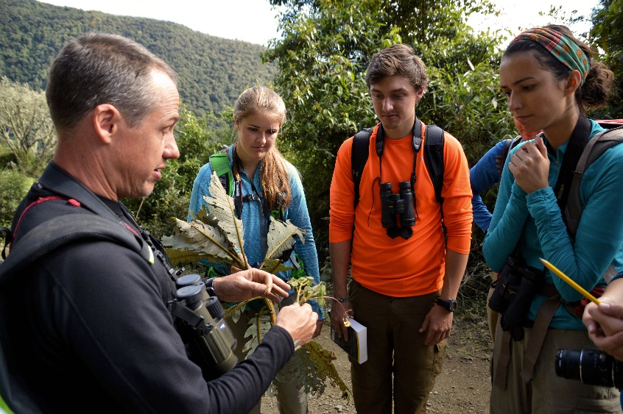
Course Requirements and Expectations:
This course is graded on a P/F basis. To pass, you must earn a comprehensive total of 140 points out of 200 (70%) which is C-. To pass in this course, you must do the following:

Attend class/Complete quality assignments
Show up to class each week, do the readings, watch the videos, and complete the assignments. Assignments and posts on discussion boards should be thoughtful and submitted in complete sentences, without typos. Missing more than two modules will result in an automatic fail for the course.

Submit assignments via the course Canvas site (e.g., Tyson_Culture Think Sheet.doc)

**You will be asked to edit or redo assignments that have deficits in content and/or quality – please take the time to do them well the first time.

Weekly Assignments
There are two assignments that will be given weekly to help in your preparation for going abroad.

Country Findings (5pts each - 30 total, 15%):
Each week, you will need to research a particular topic related to the country in which you will be studying abroad and discover something that is new to you. This exercise is intended for you to dig deeper into the cultural pieces that make your country special, so use this exercise to further explore your personal interests within the subject.
For this assignment, you will need to provide a link to the article or website of you finding, include a short summary of the article, and tell us why it is of interest to you. This does not need to be longer than a few sentences, but your responses should be thoughtful.

Study Abroad Prep (5pts each - 30 total, 15%):
Each week, you will need to research or complete a task that will better prepare you for your journey abroad. These assignments are intended to give you the tools to better prepare for going abroad as well as help you navigate your new home once you arrive.

Other Assignments (60pts in total, 30% of grade)
In addition to the weekly assignments, you will be given various readings, videos and exercises to further your understanding of your host culture and consider different perspectives to take with you on your time abroad. These assignments will generally be worth between 5 and 10 points each.

FINAL ASSIGNMENTS
Explore Your City (60pts, 30% of grade)
The final assignment will be a multi-media presentation about your ideal first weekend in your host country. A good comparison could be the 36 hours series by the New York Times. Where will you eat? How will you get there? What arts and cultural exhibits will you take in? Now that you’re a local, what non-touristy things will you do? For this project, you will create a VoiceThread presentation that needs to be at least 5 minutes in total length and incorporates photos, video clips, maps or anything you need to tell the story of your first weekend. Be sure to also include a voiceover with your slides. More details about this project will be given later in the semester, but it never hurts to start thinking about your plans now.

Final Reflection Paper (20pts, 10% of grade)
You will need submit a reflection paper of 1-2 pages of what you have learned in this course and your goals for going abroad. Prompts will be provided.

Module | Date | Topic
0 | 10/14 | Course Introduction
1 | 10/19 | Exploring Your Host Country
2 | 10/26 | Culture and Stereotypes
3 | 11/2 | Cultural Values
4 | 11/9 | Intercultural Engagement
5 | 11/16 | Engaging with Others Across Difference
6 | 11/23 | Culture Shock and Stress
7 | 11/30 | Prepare for Takeoff
 | 12/4 | Last day of half-semester courses

Course Schedule:
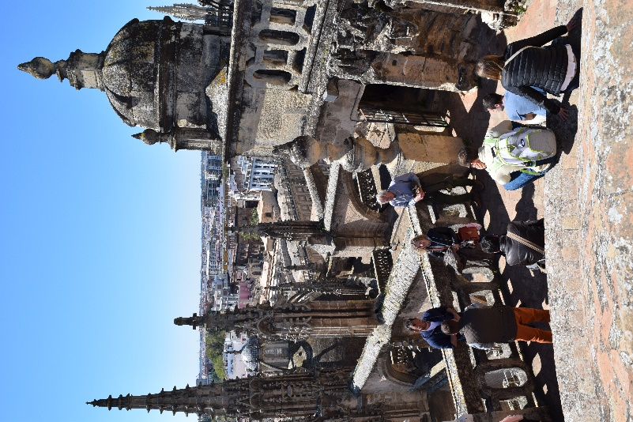

Honor Code

All students are expected to abide by the honor code and other guiding principles of the Wake Forest community. This means not cheating, plagiarizing (using someone else’s work as your own), or other academic misconduct. For this or any other class, if you have any questions about what cheating or plagiarism means, please ask me. I want you to know, so that you can avoid problems and have success with your own, honest, work.

Schedule and Topics at a Glance

Module 0: Course Introduction  Assignments due by 10/18/2020 | - Review the Course Syllabus  - Watch VoiceThread Tutorial  - Watch Instructor Introductions
Module 1: Exploring Your Host Country  Assignments due by 10/25/2020 | - Student Introductions via VoiceThread (5pts)  - Assignment: Host Country Show or Film and Questions (5pts)  - Country Findings (Government and Politics)  - Study Abroad Prep (Visas)
Module 2: Culture and Stereotypes  Assignments due by 11/1/2020 | - Watch: Danger of a Single Story  - Watch: American Stereotypes Video  - Assignment: VoiceThread Response to Videos (5pts)  - Assignment: Cultural Think Sheet (5pts)  - Country Findings (Arts/Culture)  - Study Abroad Prep (Flights)
Module 3: Cultural Values  Assignments due by 11/8/2020 | - Read: 9 Cultural Values  - Assignment: Cultural Values Comparison and Questions (5pts)  - DAE Exercises and Questions (5pts)  - Country Findings (Food)  - Study Abroad Prep (Cooking Abroad)
Module 4: Intercultural Engagement  Assignments due by 11/15/2020 | - Read: View from the Veranda p.35-39 & p.49-55  - Read: 6 Ways to Get Involved  - Assignment: VoiceThread questions for Veranda (5pts)  - Assignment: Interview an Ambassador (10pts)  - Country Findings (Engagement activity/group)  - Study Abroad Prep (Public Transportation)
Module 5: Engaging with Others Across Difference  Assignments due by 11/22/2020 | - Watch: Empathy Video  - Assignment: Complete Identity Wheel worksheet and Questions (5pts)  - Read: Bennett’s Model of Intercultural Sensitivity  - Read: At Least 2 Identity Articles and answer questions (5pts)  - Country Findings (Diverse Identities)  - Study Abroad Prep (Budget)
Module 6: Culture Shock and Stress  Assignments due by 11/29/2020 | - Read: Culture Shock Article  - Watch: Studying Abroad Culture Shock  - Assignment: Cultural Transition Stress Reflection (5pts)  - Country Findings (Major/Minor)  - Study Abroad Prep (Lost Luggage Scenario)
Module 7: Prepare for Takeoff  Assignments due by 12/4/2020 | - Explore Your City Presentation (60pts)  - Reflection Paper (20pts)

