Quick Reference Guide:
How to Navigate WakeAbroad for Faculty Directors

- Logging in to WakeAbroad
  - Visit http://studyabroad.wfu.edu
  - Select WFU Users Login on the right side of the top toolbar.
  - Select your WFU Google Account to login.
- Accessing student applications
  - Once logged in select “Administrative” (located under the house icon on the left side of the toolbar).
  - Scroll down until you see the menu item “Shared Queries”. There you will see a link for your group. Select this link and you will be taken to a list of active student applications.
  - Click on the program name in the row with the student’s name to access the individual applications.
  - Under the student’s name, you will use the following tabs:
    - Questionnaires – View student responses to the “General Application for WFU Program.” If student has submitted this questionnaire, it will be underlined with a date submitted in parentheses. Click on the link to view. NOTE: you can select the printer icon, if you would like to actually print the application questionnaire.
    - Materials – Items that the student must submit or actions students must take. Most of these items will be received by the Center for Global Programs and Studies, checked as received, and forwarded to you. NOTE: you are responsible for checking off the step “Meet with Resident Professor.”
    - Profile – Contains student information imported from Banner; i.e. GPA, student ID number, major, minor, etc.
    - History Log – An audit trail of any action taken on a given application.
    - Email – Contact the student while you are in his/her file (see page 6). Option to use “System Email” or “Local Client.” Benefit of System Email is that it will store all correspondence with the student under this tab.
    - Status – Use this tab to Accept, Withdraw or Waitlist students. Make your decisions under the dropdown menu. When you have made your selections, be sure to hit the “Update” button at the bottom of the page. An email notification will automatically be sent to the student on the “Decision date.” If this date has passed, then the email will be sent the following day.
- Making acceptance, withdrawn, waitlist decisions
  - After reviewing student application materials, select the “Status” tab (see page 5). You can change student from pending to Accepted, Withdrawn, or Waitlist. Click “Update.”
  - Remember you can accept students before the official deadline, but the automated notification email will not be sent until the decision date. If you select a student early, it’s a good idea to notify him/her by email.

Go to studyabroad.wfu.edu to log into WakeAbroad.
Click “WFU Users Login” in the top-right.
Select your WFU Google Account to login

You will then be taken to the Admin Home page.
If you wish to quickly return to this page, select Administrative by clicking on the house icon on the left side of the toolbar.

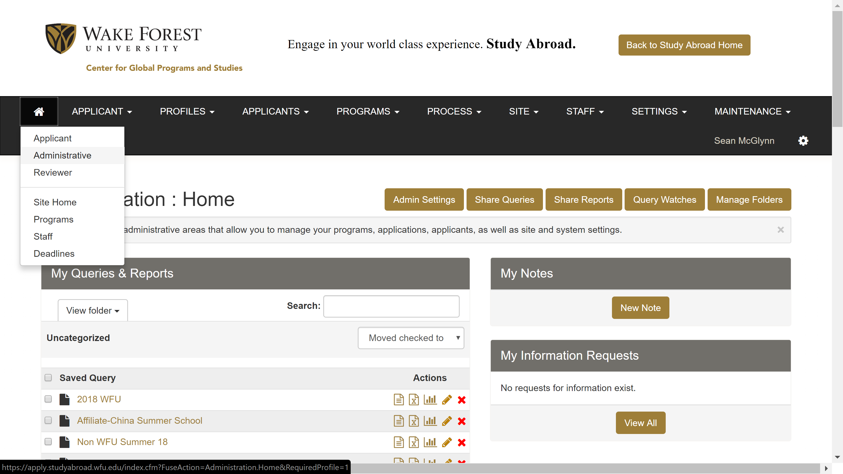
Within Admin Home, the programs you direct will appear under Shared Queries.
Select the program name’s link to view a list of active student applications.

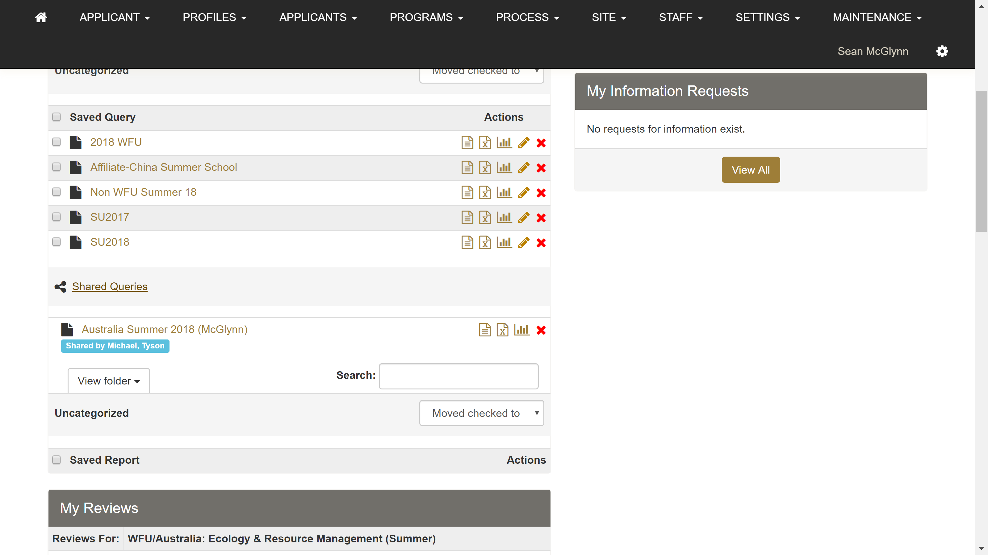

You can Group applications by Application Status (Pending, Accepted, Committed) here.
To view a student’s individual file, select the program name link in the same row as his/her name.

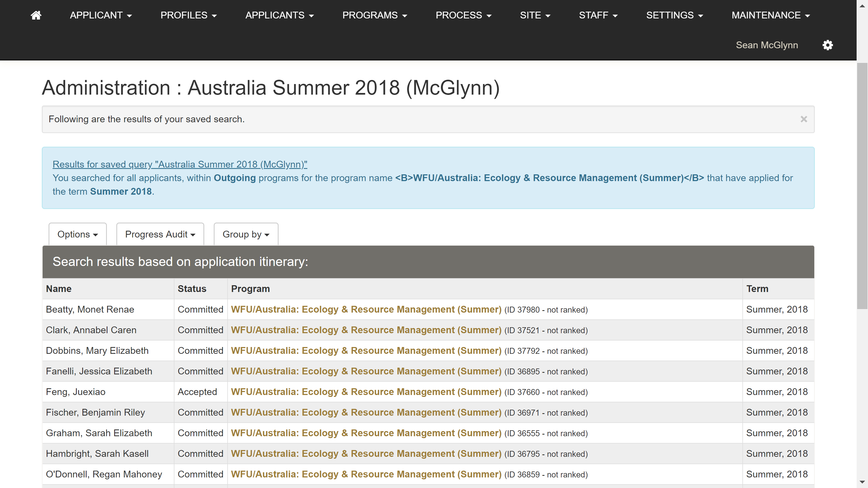
Use the tabs to access student materials/information.
The most important tabs are Questionnaires, Materials, Profile, Email, and Status.
Refer to page 1 of this handout for an explanation of these tabs.

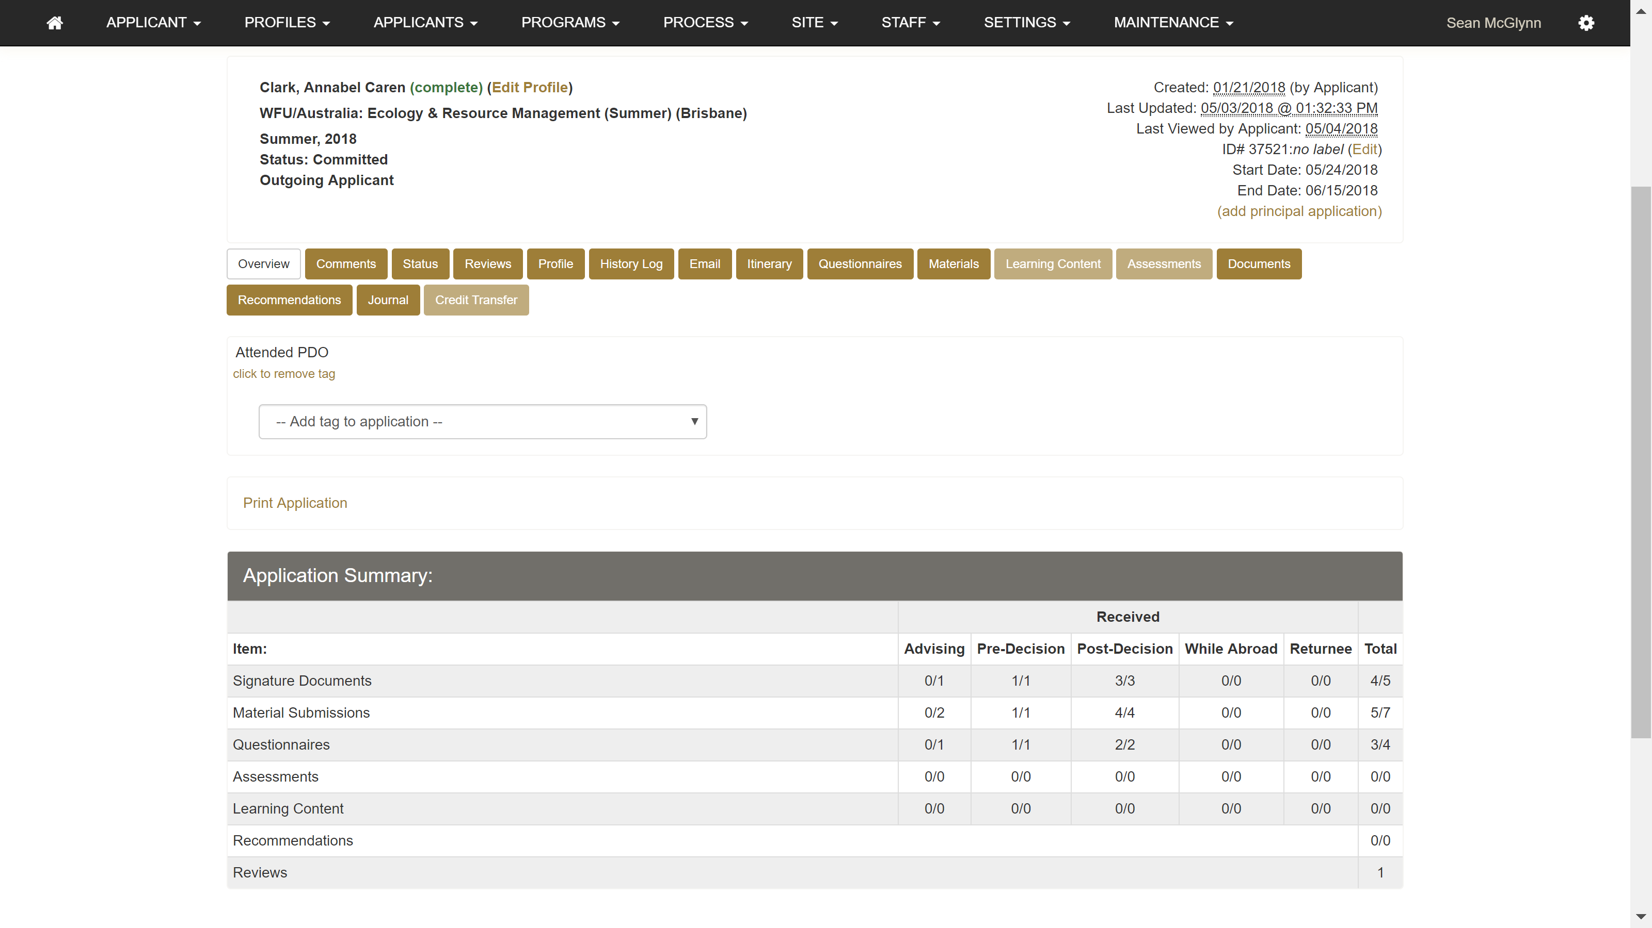
Email tab allows you to email this specific student. It records any correspondence sent via WakeAbroad with this student.
Status tab is where you will make acceptance decisions.
You can Accept, Reject, or Waitlist.
Students will be able to change their status to Committed after they have been accepted. Refer to page 1 for details.

The Email tab will provide the following options:

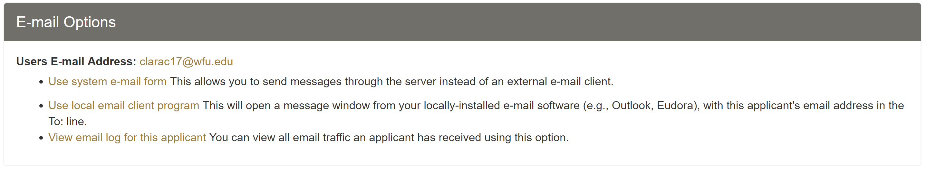
You can choose to send an email to a group of student applicants.
Return to the list of active applications for your program.
From the Options drop down, select Send email.

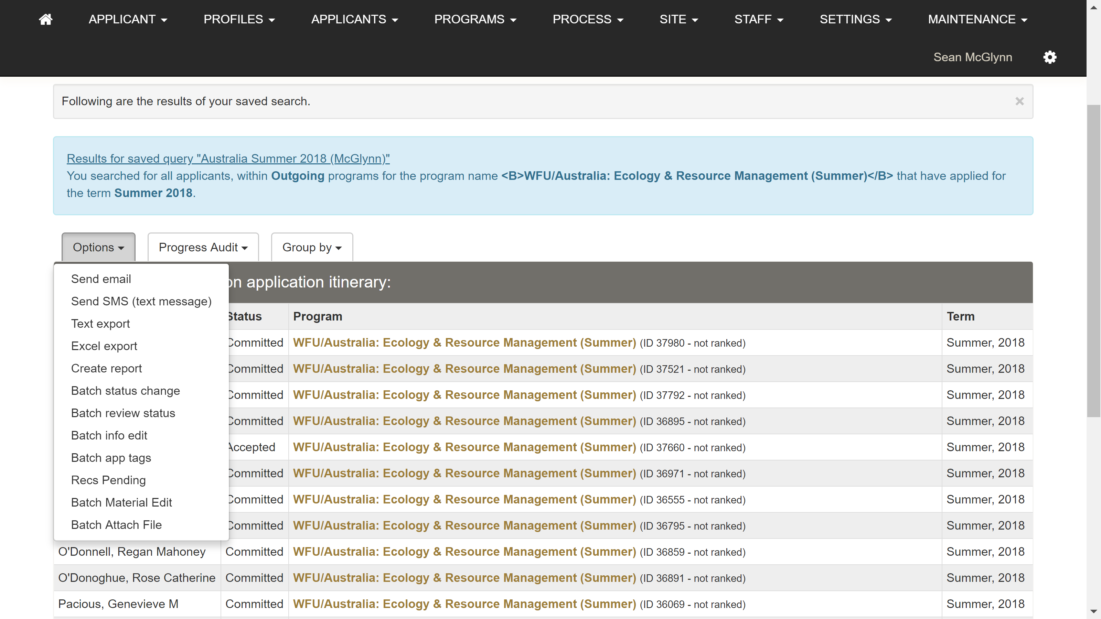
Click on the arrow next to Email Recipients to open a dropdown of the student applicants. You can choose to select specific or all students.

NOTE: The default list of recipients selects every student with an open application regardless of status (i.e. Pending, Accepted, Committed).

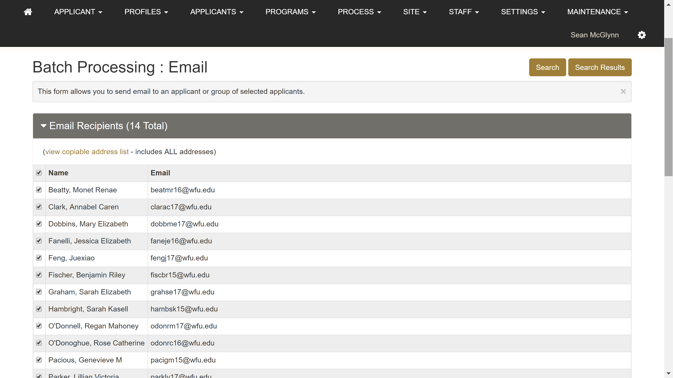

If you have any questions on using WakeAbroad or would like to set up time for individual training, please contact Michael Tyson in the Center for Global Programs and Studies at tysonmj@wfu.edu.

