Recommended Reading
Community Engagement
Leggo, Carl. 2008. “Narrative Inquiry: Attending to the Art of Discourse.” Language and Literacy 10 (1): 1–21.
Course Design and Assessment
Forum BEVI Project. Forum on Education Abroad. (n.d.). Retrieved July 17, 2015, from http://www.forumea.org/research-bevi-project
Hemming Lou, K., Paige, R. M., & Vande Berg, M. (2012). Student Learning Abroad: What Our Students are Learning, What They are Not, and What We Can Do About It (1st ed.). Sterling, VA: Stylus.
Intolubbe-Chmil, Loren, Carol A. Spreen, and Robert Swap. 2012. “Transformative Learning: Participant Perspectives on International Experiential Education.” Journal of Research in International Education 11 (2) (August): 165–180. http://jri.sagepub.com/content/11/2/165.full.pdf+html.
Tomlinson, C. (2015). Teaching for Excellence in Academically Diverse Classrooms. Society, 52(3), 203–209.
Wiggins, G. P., & McTighe, J. (2011). The understanding by design guide to creating high-quality units. Alexandria, Va: ASCD.
Higher Education Contemporary Issues
Weick, K. (1983). Educational Organizations as Loosely Coupled Systems. In The Dynamics of Organizational Change in Education (1st ed.). Berkeley, California: MCCutchan Publishing Corporation.
Lang, James. 2013. “Why They Don’t Apply What They've Learned, Parts 1-4.” The Chronicle of Higher Education, January 21, sec. Do Your Job Better, http://chronicle.com/article/Why-Dont-They-Apply-What/136753/.
Intercultural Communication
Bennett, Milton. 1998. “Intercultural Communication: A Current Perspective.” In Basic Concepts of Intercultural Communication, 1st ed., 1–34. Yarmouth, ME: Intercultural Press.
Deardorff, Darla K. 2010. “Theory Reflections: Intercultural Competence Framework/Model ”. Presentation presented at the NAFSA. http://www.nafsa.org/_/file/_/theory_connections_intercultural_competence.pdf.
Understanding Elements of Culture
Bourdieu, Pierre. Chapter 2. In Outline of a theory of practice. Translated by R. Nice. Cambridge University Press, 1977.
Delaney, Carole. "Disorientation and Orientation." In Investigating Culture: An Experiential Introduction to Anthropology. Wiley Blackwell, 2011. pp.1-25.
Starr, J., & Wang, C. (2015). Making Culture Visible [Online Course]. Retrieved July 10, 2015, from https://coreculturevisible.wordpress.com/syllabus/

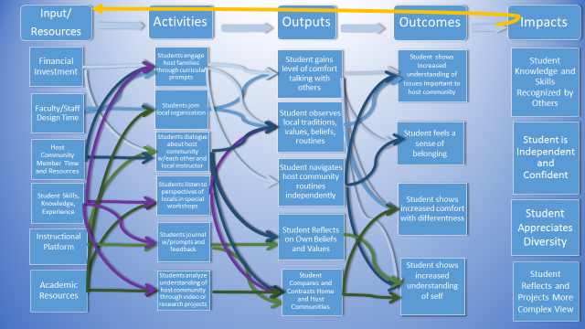
IFSA-Butler C&C Program Logic Model

