

**Student Health will be administering flu shots…**

**5:00 – 7:00 PM**

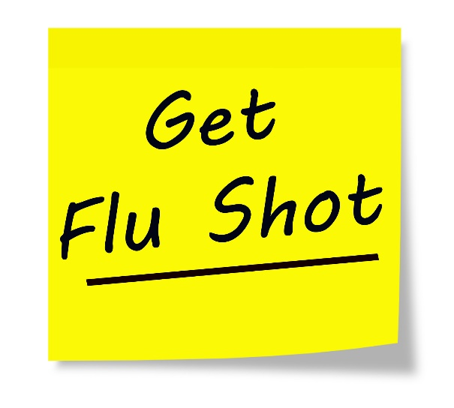

**Tuesday, Nov. 8th**

**South Lounge**

**Tuesday, Nov. 15th Taylor Lounge Thursday, Nov. 17th**

** Dogwood Lounge**

**$27 Fee will be charged to your student account**