Accessing Electronic 1098-T Forms via WIN

Electronic 1098-T tax forms are available for all enabled tax years via WIN. In order to view the tax forms, the student must provide consent. At any time, the student can remove his/her consent.
To access the 1098-T screens, follow these instructions:
Log into WIN at https://win.wfu.edu and then navigate to ‘Personal’.
To provide (or remove) consent, click on the ‘1098-T Electronic Consent’ link.  If consent has already been given, click on ‘1098-T Tax Form’. | 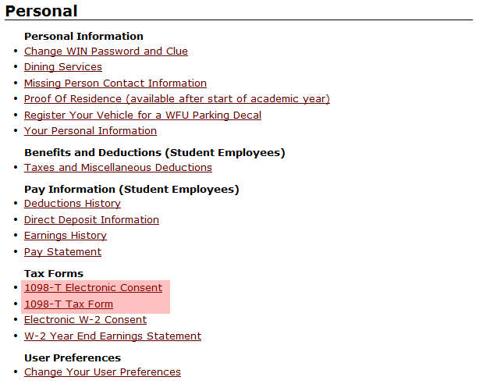
In order to provide consent, click the checkbox and then press the ‘Submit’ button.  To remove consent, uncheck the checkbox and press the ‘Submit’ button. | 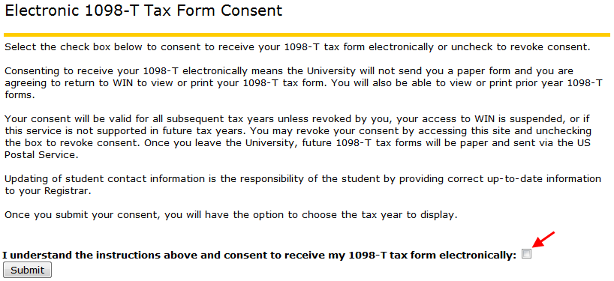
Once consent has been submitted or the user selected ‘1098-T Tax Form’ from the ‘Personal’ menu, the user must select the tax year.  Once the desired tax year is chosen, press the ‘Submit’ button and the 1098-T will be displayed.  Note: If the user navigated directly to this screen via the ‘1098-T Tax Form link and has NOT consented, the user will be taken back to the consent screen once the ‘Submit’ button is pressed. | 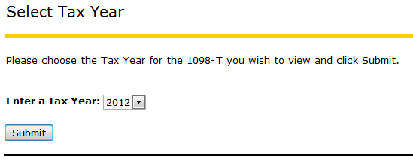
The 1098-T form is displayed.  Note: Only the last 4 digits of the student’s SSN is displayed. | 